 | 

35” AND 39” LOW TEMP

GLASS FRONT MERCHANDISER
ILLUSTRATED PARTS MANUAL

LOO76, REV. J

 | AUTOMATED MERCHANDISING SYSTEMS INC  255 WEST BURR BLVD.  KEARNEYSVILLE, WV 25430  304-725-6921 - Fax 304-725-6983  info@amsvendors.com  www.amsvendors.com | INTERNATIONAL A.M.S. S DE RL DE CV  KM. 9 CARR. AL CASTILLO NO. 8200  MPIO. DE EL SALTO, JAL. MEXICO 45680  5233-3-6-88-07-17 - Fax 5233-3-6-88-13-14  servicio@amsint.com.mx  www.amsint.com.mx

AMS Glass Front Merchandiser
35” & 39” LOW TEMP
Illustrated Parts Manual

Table of Contents
SECTION PAGE
INTRODUCTION
Table of Contents 3
General Introduction 4
Manual Organization 4
Merchandiser Identification 5
Patent Disclosure 6
Publication Notice 6

CABINET
Cabinet Components and Screens 8
Cabinet and Parts for VCB and VCF Vendor 10

CHILLER
Chiller Parts – Side View 14
Chiller Parts – Top View 16

DOOR
Door, Coin Bay 18
Door, Hinges, Lighting and Glass 20
Door, External Parts 24
Door, Hopper with Sensit III 28
POS Display 30

ELECTRICAL HARNESSES 32

TRAYS
1.5” Helix Tray 54
Bottle Tray 56
Snack, Candy, Food Tray 58
Scrolling Price Tray 60
Helix 62

GENERAL INTRODUCTION

The purpose of this manual is to give our customers a way of identifying major service parts for repair and replacement. The illustrations and parts list in this manual are for identification of these service parts only.

Illustrations of these major parts are keyed with our part numbers. The illustrations help identify the general design, position and orientation of these parts. The note section may also give important information.

Please refer to the section on merchandiser identification on the following pages. Without the model style and serial number it may be difficult to identify the required part.

Parts should be ordered from your distributor.

It is our intent to assist our customers with up-to-date documentation. However, this manual may not show all parts, variations or changes. Some parts may be shown slightly out of scale. This manual is itself subject to change without notice. If any errors are found, please notify AMS so the correction can be included in later revisions. Engineering data and third party information are generally not included. The graphical data, group assembly data, parts, part assembly, parts breakout information and tabular data conveyed by this manual is proprietary and belongs to AMS, and holders without prior consent of or without knowledge of and by AMS must surrender this data immediately.

All measurements are in inches except where specified as Metric.

MANUAL ORGANIZATION

This manual is divided into sections representing the general parts of our merchandisers. Each section is further divided into the various subsections or subassemblies of the machine. Each subsection leads off with one or more illustrations showing the parts. Each part shown is identified with the part number.

After the illustrations, the part number in the illustration is paired with our drawing description or title for that part. In some instances there may be multiple parts to choose from. However, the correct service or repair part for the style of merchandiser must be selected. There is a note section where additional information may be found.

A quantities column in the list provides information on the total quantities required for each set-up as shown. Some assemblies are fabricated as a unit at AMS and are replaceable only as a complete assembly. Optional parts identify parts contracted for and installed in the factory at AMS.

This manual contains model and style information for a vendor as found in previous revisions or parent manuals, including corrections. It may also contain additional and new information, especially if it is specific to your new vendor. Previous revisions of this manual should be kept for use with the vendor it was issued for.
MERCHANDISER IDENTIFICATION

When requesting service, replacement parts or technical assistance, please use the Model Number and the Serial Number with Date Code, found on the Serial Plate (Refer to Figure 1) affixed to the merchandiser. The plate is usually located inside the door, visible through the window. The information contained on this plate is necessary to determine what parts, kits, or maintenance apply to your vendor.
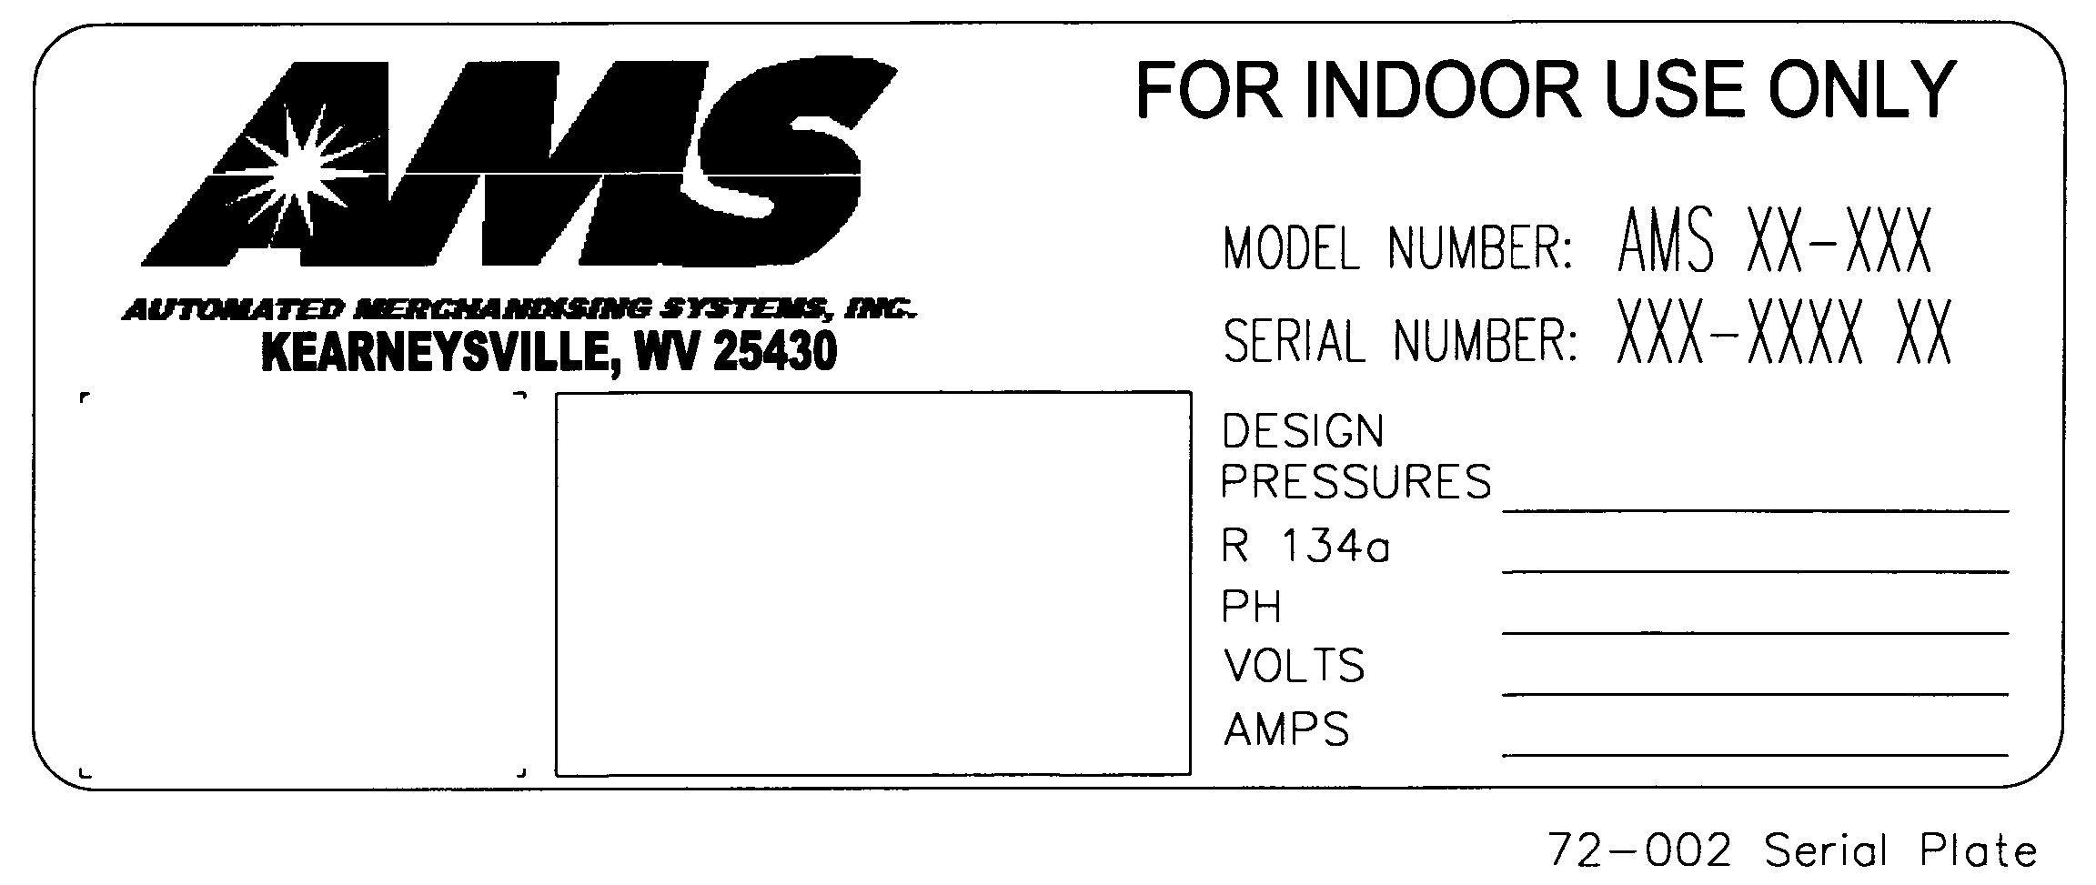
Figure 1. Example of Typical Serial Plate

Example of Model Number Breakdown  AMS 39 – VCB  Manufacturer Cabinet Width Model  Example: AMS39-VCB means this vendor is an Automated Merchandising Systems merchandiser, 39” wide, without Health and Safety protection. | Example of Serial Number and Date Code Breakdown  1 - 0902 - 0275  Built Year Month Sequence  Example: 1-0902-0275 is translated as U.S. built (1), manufactured in 2009, month of February, and was the 275th manufactured that year.  Note: Manufactured in Mexico, Built = (2)

PATENT DISCLOSURE

This merchandiser and/or certain of its components are covered by one or more of the following U.S. and international patents;

U.S. PATENTS: 6,041,962; 6,145,699; 6,202,888; 6,384,402; 6,520,373; 6,708,079; 6,794,634; 7,191,915; 7,343,220; 7,446,302; 7,742,837, 8,003,931.

CANADIAN PATENT 2,329,314.

MEXICO PATENT 230714.

PUBLICATION NOTICE

L0076, Revision H, 12/23/13

It is our intent to assist our customers with up-to-date documentation: however, this manual may not contain all updates and is subject to revision without notice. Please contact our Service Department with your requests or comments.

THIS PAGE INTENTIONALLY LEFT BLANK

CABINET COMPONENTS AND SCREENS ILLUSTRATION

CABINET COMPONENTS AND SCREENS PARTS LIST
ITEM | PART NO. | PART DESCRIPTION | NOTES
1 | 20608 | POWER CORD COVER
2 | 20019 | ROLLER BRACKET
3 | 20121 | LEVELING LEG
4 | 20177 | ROLLER
5 | 20275 | REAR & BOTTOM TRIM CHILLER HOLE
6 | 20279 | SCREEN, REAR CHILLER HOLE, 4 MESH
7 | 20321 | IEC INLET COVER
8 | 21122 | FRONT LEG ASSEMBLY
9 | 21123 | LEFT FRONT LEG ASSEMBLY
10 | 21124 | REAR LEG ASSEMBLY | (QTY 2)
11 | 21250 | ROLLER SHAFT
12 | 23231 | SHIPPING BOARD | 40” LONG, NOT TREATED, (DOM)
12 | 23231-02 | SHIPPING BOARD | 38-3/8” LONG, NOT TREATED, (DOM)
12 | 23231-01 | SHIPPING BOARD | 40” LONG, TREATED (ISPM 15), (EXPORT)
12 | 23231-03 | SHIPPING BOARD | 38-3/8” LONG, TREATED (ISPM 15), (EXPORT)
13 | 21463 | SCREEN, BOTTOM CHILLER HOLE, 4 MESH (35”) | Contact AMS for your application
13 | 21469 | SCREEN, BOTTOM INSECT (35”) | Contact AMS for your application
13 | 23262 | CONDENSER SCREEN ASSEMBLY (39”) | Contact AMS for your application
14 | 20275 | REAR & BOTTOM TRIM CHILLER HOLE (39”) | Contact AMS for your application
14 | 21464 | BOTTOM TRIM CHILLER HOLE (35”) | Contact AMS for your application
14 | 23209 | BOTTOM TRIM CHILLER W/ REMOVABLE SCREEN (39”) | Contact AMS for your application
14 | 23263 | CONDENSER SCREEN HOLDER ASSEMBLY (39”) | Contact AMS for your application
15 | 3000 | SHEET METAL SCREW (1/4” HEX)
16 | 3057 | IEC INLET
17 | 3080 | STRAIN RELIEF
18 | 3113 | 3/16 PUSH NUT
19 | 3827 | POWER ENTRY MODULE, 230V | EUROPE ONLY
20 | 25462 | PLATE, POWER ENTRY MODULE, CE | EUROPE ONLY

CABINET PARTS FOR 35” AND 39” LOW TEMP ILLUSTRATION

CABINET PARTS FOR 35” AND 39” LOW TEMP PARTS LIST
ITEM | PART NO. | PART DESCRIPTION | NOTES
1 | 20135 | LOCK, FLANGE
2 | 20136 | LOCK, CAGE
3 | 20213 | FLANGE, RIGHT VERTICAL
4 | 20291 | COVER PLATE, HINGE HOLE
5 | 20481 | LEFT VERTICAL RAIL EXTENSION
6 | 22006 | BULKHEAD ASSEMBLY, VISI-COMBO (35”) | OPTIONAL, CONTACT AMS FOR YOUR APPLICATION
6 | 20790 | BULKHEAD ASSEMBLY, VISI-COMBO (39”) | OPTIONAL, CONTACT AMS FOR YOUR APPLICATION
6 | 24280 | ASSY., BULKHEAD, MU | OPTIONAL, CONTACT AMS FOR YOUR APPLICATION
7 | 20880 | TRANSFORMER COVER PLATE
8 | 20882 | COVER PLATE
9 | 21975 | BULKHEAD, RIGHT RAIL MOUNT (35”)
9 | 20907 | BULKHEAD, RIGHT RAIL MOUNT (39”)
10 | 21053 | STIFFENER
11 | 21087 | DOOR SWITCH PLATE
12 | 21324 | WARNING DECAL
13 | 21913 | RIGHT RAIL MOUNT, VERTICAL (35”)
13 | 21477 | RIGHT RAIL MOUNT, VERTICAL (39”)
14 | 21479 | SWITCH AND FUSE HOLDER PLATE
15 | 21509 | FUSE DECAL
16 | 21839 | LEFT VERTICAL RAIL MOUNT
17 | 21691 | FAN SWITCH ENCLOSURE
18 | 22005 | RAIL MOUNT DOOR ASSEMBLY
19 | 22041 | TRAY POSITION DECAL
20 | 21989 | CABINET ASSEMBLY(35”) | CONTACT AMS FOR YOUR APPLICATION
20 | 22071 | CABINET ASSEMBLY(39”) | CONTACT AMS FOR YOUR APPLICATION
21 | 3000 | SHEET METAL SCREW (1/4” HEX)
22 | 3009-02 | 1/8” RIVET (1/8” GRIP)
23 | 3009-04 | 1/8” RIVET (1/4”) GRIP
24 | 3010 | SQUARE MACHINE NUT
25 | 3018-06 | SHEET METAL SCREWS (3/8” HEX)
26 | 3024-12 | CABLE CLAMP
27 | 3030 | RFI FILTER 115V | NON-EUROPE ONLY, CHECK UNIT VOLTAGE
28 | 3133-30 | FUSE HOLDER
29 | 3199 | ROCKER SWITCH N/O
30 | 3205-34 | GROMMET
31 | 3229 | 4” EXTENSION SPRING | NOT SHOWN
32 | 3257 | TRANSFORMER 120V – 2 USED | CHECK UNIT VOLTAGE
32 | 3258 | TRANSFORMER 220V – 2 USED | CHECK UNIT VOLTAGE
33 | 3274 | RELAY
34 | 3284 | ROCKER SWITCH
35 | 21079 | CABLE ASSEMBLY, DOOR STOP | NOT SHOWN

THIS PAGE INTENTIONALLY LEFT BLANK
CHILLER PARTS ILLUSTRATION – SIDE VIEW

CHILLER – SIDE VIEW PARTS LIST
ITEM | PART NO. | PART DESCRIPTION | NOTES
1 | 3000 | SHEET METAL SCREW TEK #8-18
2 | 3018-06 | SCREWS, ¼ X ¾, SELF TAPPING, HEX HEAD | FOR ATTACHING TO TANK WALLS
3 | 3018-08 | SCREWS, ¼ X 1, SELF TAPPING, HEX HEAD | FOR ATTACHING TO TANK FLOOR
4 | 3106 | EVAPORATOR FAN/MOTOR ASSEMBLY, 220V, 50Hz, 1 PHASE (VCB/VCF MODELS) | NOTE VOLTAGE
5 | 3107 | EVAPORATOR FAN/MOTOR ASSEMBLY, 115V, 60Hz, 1 PHASE (VCB/VCF MODELS) | NOTE VOLTAGE
5 | 3819 | EVAPORATOR FAN/MOTOR ASSEMBLY, (LB/LC MODELS), 115V, 50/60 Hz | NOTE VOLTAGE
6 | 21987 | EVAPORATOR COVER PLATE
7 | 20317 | EVAPORATOR PLENUM | CONTACT AMS FOR YOUR APPLICATION
7 | 20658 | EVAPORATOR PLENUM (VISI-COMBO) | CONTACT AMS FOR YOUR APPLICATION
8 | 22889 | ASSEMBLY, 1/2, CHILLER, 115V | SEE NOTE. CONTACT AMS FOR YOUR APPLICATION
8 | 22928 | ASSEMBLY, 1/2, CHILLER, 240V | SEE NOTE. CONTACT AMS FOR YOUR APPLICATION
8 | 24712 | ASSEMBLY, MODULAR UNIT, 115V (LB/LC MODELS) | SEE NOTE. CONTACT AMS FOR YOUR APPLICATION
9 | 21888 | ASSEMBLY, CHILLER HOUSING (35”) | HOUSING MUST SEAL AGAINST CABINET AS SHOWN.
9 | 23219 | ASSEMBLY, CHILLER HOUSING, ENGLISH (39”) | HOUSING MUST SEAL AGAINST CABINET AS SHOWN. SUPPLIED WITH ACCESS DOOR.
9 | 23219-01 | ASSEMBLY, CHILLER HOUSING, SPANISH (39”)
9 | 24361 | ASSEMBLY, TOP BULKHEAD, CHILLER COVER, LB/LC, 39”
9 | 24367 | ASSEMBLY, TOP BULKHEAD, CHILLER COVER, LB/LC, 35”
10 | 21424 | BRACKET, TEMPERATURE SENSOR
11 | 21989 | CABINET ASSEMBLY(35”) | CONTACT AMS FOR YOUR APPLICATION
11 | 22071 | CABINET ASSEMBLY(39”) | CONTACT AMS FOR YOUR APPLICATION
12 | 21990 | BASE, STAMPED EVAPORATOR DRAIN PAN | FOR STAMPED PAN ASSEMBLIES
13 | 21992 | ASSEMBLY, STAMPED EVAPORATOR DRAIN PAN | USE WITH 21990, DRAIN PAN BASE
NOTE: Chiller assemblies are charged with refrigerant and are replaceable only as an assembly. The refrigeration system is pressurized and sealed at the factory. Puncturing or cutting any component in the system will cause refrigerant gas and liquid to be propelled out of the system, creating an immediate physical hazard. Use caution to avoid accidentally opening the refrigerant system. It should also be noted that releasing refrigerant to the atmosphere is a federal crime and is punishable by law. Any service work requiring the system to be opened must be performed by a licensed technician using certified recovery equipment. Unauthorized service to the sealed refrigerant system may void the warranty.

CHILLER PARTS ILLUSTRATION – TOP VIEW

CHILLER PARTS LIST – TOP VIEW
ITEM | PART NO. | PART DESCRIPTION | NOTES
1 | 3065 | FAN, CONDENSER ASSEMBLY, 220V, 50 Hz, 1 PHASE | NOTE VOLTAGE
1 | 3108 | FAN, CONDENSER ASSEMBLY, 115V, 60Hz, 1 PHASE | NOTE VOLTAGE
1 | 3819 | EVAPORATOR FAN/MOTOR ASSEMBLY, (LB/LC MODELS), 115V, 50/60 Hz | NOTE VOLTAGE
2 | 3093 | SPONGE (CONDENSER DRAIN PAN)
2 | 3093-01 | SPONGE (BLUE) LB/LC MODELS
3 | 20144 | REFRIGERATION HARNESS (VCB/VCF MODELS) | USE WITH BOTH 115V OR 220V SYSTEMS
3 | 22653 | REFRIGERATION HARNESS, LB/LC MODELS | USE WITH BOTH 115V OR 220V SYSTEMS
4 | 22889 | ASSEMBLY, 1/2, CHILLER, 115V (VCB/VCF MODELS) | SEE NOTE. CONTACT AMS FOR YOUR APPLICATION
4 | 22928 | ASSEMBLY, 1/2, CHILLER, 240V (VCB/VCF MODELS) | SEE NOTE. CONTACT AMS FOR YOUR APPLICATION
4 | 24712 | ASSEMBLY, MODULAR CHILLER, 115V (LB/LC MODELS) | SEE NOTE. CONTACT AMS FOR YOUR APPLICATION
5 | 21990 | BASE, STAMPED EVAPORATOR DRAIN PAN (VCB/VCF MODELS) | FOR STAMPED PAN ASSEMBLIES
6 | 21992 | ASSEMBLY, STAMPED EVAPORATOR DRAIN PAN | USE WITH 21990, DRAIN PAN BASE
6 | 24287 | ASSEMBLY, MOLDED EVAPORATOR DRAIN PAN (LB/LC MODELS)
7 | 22048 | CONDENSER DRAIN PAN (VCB/VCF MODELS)
7 | 24585 | CONDENSER DRAIN PAN (LB/LC MODELS)

NOTE: Chiller assemblies are charged with refrigerant and are replaceable only as an assembly. The refrigeration system is pressurized and sealed at the factory. Puncturing or cutting any component in the system will cause refrigerant gas and liquid to be propelled out of the system, creating an immediate physical hazard. Use caution to avoid accidentally opening the refrigerant system. It should also be noted that releasing refrigerant to the atmosphere is a federal crime and is punishable by law. Any service work requiring the system to be opened must be performed by a licensed technician using certified recovery equipment. Unauthorized service to the sealed refrigerant system may void the warranty.

COIN BAY DOOR ILLUSTRATION

COIN BAY DOOR PARTS LIST
ITEM | PART NO. | PART DESCRIPTION | NOTE
1 | 3000 | Screw, Sheet Metal TEK 8-18
2 | 3005-04 | Carriage Bolt, #10-24,1/2"
3 | 3006-08 | Nut, Hex, Machine Screw, #8-32 | 4 per DBV Opening
4 | 3006-10 | Nut, Hex, Machine Screw, #10-24
5 | 3009-04 | Rivet, Steel, 1/8", Black, Grip Length 1/4"
6 | 3017-06 | Washer, Flat Steel, SAE Std., #6
7 | 3017-10 | Washer, Flat Steel, SAE Std., #10
8 | 3037-1 | PC Board Support (3/16") | For Control Board
9 | 3038 | Rivet, Nylon, Trim | Hold Door Closed
10 | 20081-01 | Scavenger Button, Blk
11 | 24631 | Assy., Coin Chute, Upper
12 | 24641 | Scavenger Guide, Epoch
13 | 23373 | Assembly, Plastic Coin Cup
14 | 24961 | Coin Box Bulkhead
15 | 20181 | DBV Cover Plate | Flat Steel Plate, 1 per DBV Opening
16 | 24962 | Assembly, Coin Chute, Lower
17 | 24642 | Bracket, Pushbutton Alignment, Epoch
18 | 24613 | Assembly, Coin Box
19 | 20706 | Door Stiffener, Upper, Without Fuse And Switch
19 | 20709 | Door Stiffener, Upper, Locking, W/O Fuse And Switch | Not Shown
20 | 20707 | Door Stiffener, Bottom with Switch
21 | 22004 | Assembly, Upper Coin Door, Low Temp
22 | 25655 | Control Board, Sensit 3
23 | 24608 | Mounting Panel, Changer, Multi-Use
24 | 24739 | Assembly, Display, VER 3, Escutcheon, Sensit II
25 | 24625 | Assembly, Scavenger System Escutcheon, VER. 3
26 | 25212 | Assy., Foamed Door, L/T, Epoch (35”) | Contact AMS for your application.
26 | 25203 | Assy., Foamed Door, L/T, Epoch (39”) | Contact AMS for your application.
26 | 25244 | Assy., Foamed Door, L/T, Epoch-ADA (39”) | Contact AMS for your application.
DOOR HINGES, LIGHTING AND GLASS ILLUSTRATION

DOOR HINGES, LIGHTING AND GLASS PARTS LIST
ITEM | PART NO. | PART DESCRIPTION | NOTE
1 | 3000 | Screw, TEK 8-18
2 | 3004-06 | Carriage Bolt, ¼-20, ¾”
3 | 3009-02 | Rivet, Pop, Steel, 1/8 Diameter
4 | 3018-06 | Screw, ¼ X ¾, Self Tapping, Hex Head | For Glass Retainers
5 | 3056 | Starter, FS2 | For Single Fluorescent Lamp , 110V
5 | 3163 | Starter, S10 | For Single Fluorescent Lamp , 230V, 50 Hz.
6 | 3072-06 | Screw, Machine, #4-36 (3/4” Long) | For Single Fluorescent Lamp, 110V
7 | 3105 | Fluorescent Lamp, 18”, 1” Diameter | For Single Fluorescent Lamp, 110V
7 | 23522 | Lamp, LED, 24” | For Single LED Option
8 | 3153-11 | Nut, Hex With Lock Washer
9 | 23521 | Lamp, LED, 42” | For Dual LED Option
9 | 25115 | Lamp, LED, 35” | For Dual LED Option in 39” Epoch ADA
10 | 23522 | Lamp, LED, 24” | For Dual LED Option
11 | 3024-16 | Cable Clamp, Black Nylon (1” Dia.) | For Dual LED Option
12 | 3342-04 | Screw, Sheet Metal, Tek 8-18, Clear Zinc, ½” L | For Dual LED Option
13 | 3279 | Lamp Cover, T8, 18”, Clear, With End Caps | For Single Lamp Option
14 | 22381 | Retainer, Vertical Eyelet
15 | 20206 | Hinge, Washer Plate
16 | 23658-01 | Retainer, 1" Dual Pane Glass, Bottom Deflector (39")
16 | 24034-01 | Retainer, 1" Dual Pane Glass, Bottom Deflector (35")
17 | 21703 | Assembly, Top Hinge, 3/16”
18 | 21704 | Assembly, Bottom Hinge Bottom, 3/16”
19 | 24761-13 | Extrusion, Glass Installation, Ver. 2, 16.91 (35”) | Horizontal, Use with Glass
19 | 24761-11 | Extrusion, Glass Installation, Ver. 2, 22.38 (39”) | Horizontal, Use with Glass
20 | 24761-14 | Extrusion, Glass Installation, Ver. 2, 36.59 (35”) | Vertical, Use with Glass
20 | 24761-12 | Extrusion, Glass Installation, Ver. 2, 37.68 (39”) | Vertical, Use with Glass
20 | 24761-16 | Extrusion, Glass Installation, Ver. 2, 31.68 (Epoch-ADA 39”) | Vertical, Use with Glass
21 | 20401 | Retainer, Horizontal Eyelet
22 | 24123 | Assembly, Lamp Bracket, Single (35”) | For Single Fluorescent Lamp, 110V
22 | 20579 | Lamp Mtg. Bracket, Universal (39”) | For Single Fluorescent Lamp, 110V and 230V
23 | 22068 | Assembly, Lock Bolt Cover, L/T
23 | 25299 | Assembly, Lock Bolt Cover, L/T 39” ADA
24 | 20857 | Lock Bolt Bracket
25 | 20852 | T-Handle Seal
26 | 20965-01 | Tray Restraint, Low Temp, Reduced Depth
26 | 25124 | Tray Restraint, Low Temp, Reduced Depth ADA
27 | 3342-04 | Sheet Metal Screw (1/4” Hex x ½”)
28 | 22036 | Glass Retainer Corner
29 | 24035 | WINDOW, GLASS, 1” DUAL PANE (39”)
29 | 24036 | WINDOW, GLASS, 1” DUAL PANE (35”)
29 | 25095 | WINDOW, GLASS, 1” DUAL PANE L/T (39”), EPOCH-ADA
30 | 23657-01 | VERTICAL GLASS RETAINER(39”)
30 | 25288-01 | VERTICAL GLASS RETAINER, EPOCH-ADA (39”)
30 | 24033-01 | VERTICAL GLASS RETAINER, (35”)
31 | 23656-01 | TOP GLASS RETAINER, (39”)
 | 24032-01 | TOP GLASS RETAINER, (35”)
32 | 24099 | CORNER, WINDOW TRIM

THIS PAGE INTENTIONALLY LEFT BLANK

DOOR, EXTERNAL PARTS ILLUSTRATION

DOOR, EXTERNAL PARTS LIST
ITEM | PART NO. | PART DESCRIPTION | NOTE
1 | 3000 | Screw, Sheet metal, TEK 8-18 | For Securing Trim
2 | 3172-02 | Rivet, Aluminum, ¼” Diameter, Natural (1/4” Grip) | For Securing Window Covers
3 | ---------- | Window Cover, Polycarbonate (35”), | Contact AMS for your application
3 | ---------- | Window Cover, Polycarbonate (39”), | Contact AMS for your application
4 | 21535-02 | Trim, Plastic Insert, For Recessed Base (31.93”) (35”) | Snaps into Trim Base
4 | 21535-01 | Trim, Plastic Insert, For Recessed Base (37.25”) (39”) | Snaps into Trim Base
5 | 21535-03 | Trim, Plastic Insert, For Recessed Base (65.38”) | Snaps into Trim Base
6 | 21535-06 | Trim, Plastic Insert, For Recessed Base (30.2”) | Snaps into Trim Base
7 | 21535-07 | Trim, Plastic Insert, For Recessed Base (29.4”) | Snaps into Trim Base
8 | 21535-08 | Trim, Plastic Insert, For Recessed Base (23.9”) (35”) | Snaps into Trim Base
8 | 21535-15 | Trim, Plastic Insert, For Recessed Base (29.68”) (39”) | Snaps into Trim Base
9 | 21612-02 | Recessed Trim Base With Holes, Painted (35”) | Black Paint Finish
9 | 21612-01 | Recessed Trim Base With Holes, Painted (39”) | Black Paint Finish
10 | 21612-03 | Recessed Trim Base With Holes, Painted | Black Paint Finish
11 | 21612-06 | Recessed Trim Base With Holes, Painted | Black Paint Finish
12 | 21612-07 | Recessed Trim Base With Holes, Painted | Black Paint Finish
13 | 21612-08 | Recessed Trim Base With Holes, Painted (35”) | Black Paint Finish
13 | 21612-15 | Recessed Trim Base With Holes, Painted (39”) | Black Paint Finish
14 | 25080 | Trim, Vend Eyelet
15 | 25212 | Assy., Foamed Door, L/T, Epoch (35”) | Contact AMS for your application.
15 | 25203 | Assy., Foamed Door, L/T, Epoch (39”) | Contact AMS for your application.
15 | 25244 | Assy., Foamed Door, L/T, Epoch-ADA (39”) | Contact AMS for your application.
16 | 23372 | Trim, Plastic Coin Cup
17 | 3005-04 | 10-24 Carriage Bolt
18 | 20130 | T-Handle Assembly
19 | 20131 | Lock Cylinder
20 | 22175 | Lens, Escutcheon, GFM
21 | 22177 | Button, .090” Dia. Round, Escutcheon
22 | 22184-01 | DBV Cover Panel, Gray | Optional

23 | 24616 | Escutcheon, Plastic, Epoch
24 | 24746 | Led Driver, Keypad
 | 24623 | Escutcheon/Keypad Assy | Includes Escutcheon, Lighted Keypad & Buttons  and Display Lens
25 | 24782 | Membrane Switch Mounting Plate, 4/76 x 3.57
26 | 25688 | Assembly, Lighted Keypad

THIS PAGE INTENTIONALLY LEFT BLANK
DOOR, PRODUCT HOPPER ILLUSTRATION

DOOR, PRODUCT HOPPER PARTS LIST
ITEM | PART NO. | PART DESCRIPTION | NOTE
1 | 21442 | ASSY., PRODUCT SENSOR EMITTER | OPTIONAL ITEM
2 | 21443 | ASSY., PRODUCT SENSOR DETECTOR | OPTIONAL ITEM
3 | 22218-01 | LEFT PRODUCT KICKER W/O FLANGE | OPTIONAL ITEM
4 | 22219-01 | RIGHT PRODUCT KICKER W/O FLANGE | OPTIONAL ITEM
5 | 22387 | DEFLECTOR PLATE, 1.5” HELIX TRAY RH (39” ONLY) | REQUIRED WITH 1.5” HELIX TRAY (39”)
6 | 22387-01 | DEFLECTOR PLATE, 1.5” HELIX TRAY LH (39” ONLY) | REQUIRED WITH 1.5” HELIX TRAY (39”)
7 | 21625 | CLEANING DECAL
8 | 21690 | DOOR SWITCH ENCLOSURE
9 | 21692 | FAN STRIKER PLATE
10 | 21798 | LENS, PRODUCT SENSOR | REQUIRED WITH ITEMS 1&2
11 | 24970 | PRIMARY SENSOR BRACKET
12 | 22126 | SECONDARY SENSOR BRACKET
13 | 22128 | SECONDARY SENSOR COVER
14 | 22130 | PRIMARY SENSOR COVER
15 | 23332 | HOPPER ASSEMBLY (35”)
15 | 22202 | HOPPER ASSEMBLY (39”)
16 | 22263 | VEND DOOR ASSEMBLY (35”)
16 | 22204 | VEND DOOR ASSEMBLY (39”)
17 | 22389 | DEFLECTOR PLATE, 2.71” Height, 1-1/8 CU Ft. Hopper (35”) | OPTION*
 | 22386 | DEFLECTOR PLATE, 2.71” Height, 1.5 CU Ft. Hopper (39”) | OPTION*
18 | 22388 | DEFLECTOR PLATE, 2.25” Height, 1-1/8 CU Ft. Hopper (35”) | OPTION*
 | 22390 | DEFLECTOR PLATE, 2.25” Height, 1.5 CU Ft. Hopper (39”) | OPTION*
19 | 24342 | PRIMARY SENSOR BOARD
20 | 24343 | SECONDARY SENSOR BOARD
21 | 3000 | SHEET METAL SCREW (1/4” HEX)
22 | 3001-03 | SHEET METAL SCREW (1/4” HEX, BLUNT TIP)
23 | 3009-04 | 1/8” X ¼ GRIP STEEL RIVET
24 | 3036 | ROCKER SWITCH
25 | 3081 | WIRE TIE, PANEL MOUNT
26 | 3205-24 | GROMMET
27 | 3342-04 | SHEET METAL SCREW (3/8” HEX)

*Use 1 of these if there is no 1.5” Helix Tray. Choose height based on lowest tray position.

POS DISPLAY ILLUSTRATION

POS DISPLAY PARTS LIST
ITEM | PART NO. | PART DESCRIPTION | NOTE
1 | 24322 | POS DISPLAY INSERT
2 | 24323 | POS DISPLAY DIFFUSER
3 | 24329 | LED BOARD
4 | 24767 | POS DISPLAY CARD (AMS) | ENGLISH
4 | 24768 | POS DISPLAY CARD (IAMS) | SPANISH
5 | 24339 | LIGHT BOX ASSEMBLY
6 | 3029-02 | BUSHING

ELECTRICAL HARNESS ILLUSTRATIONS

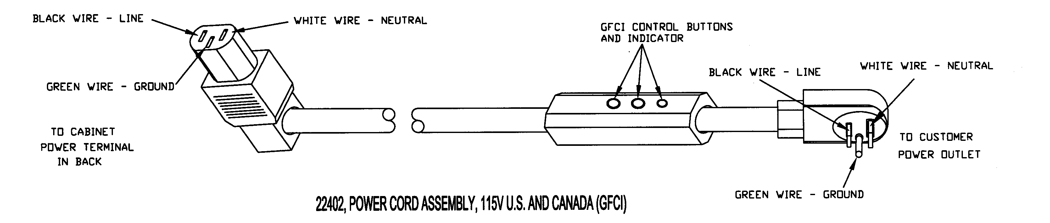

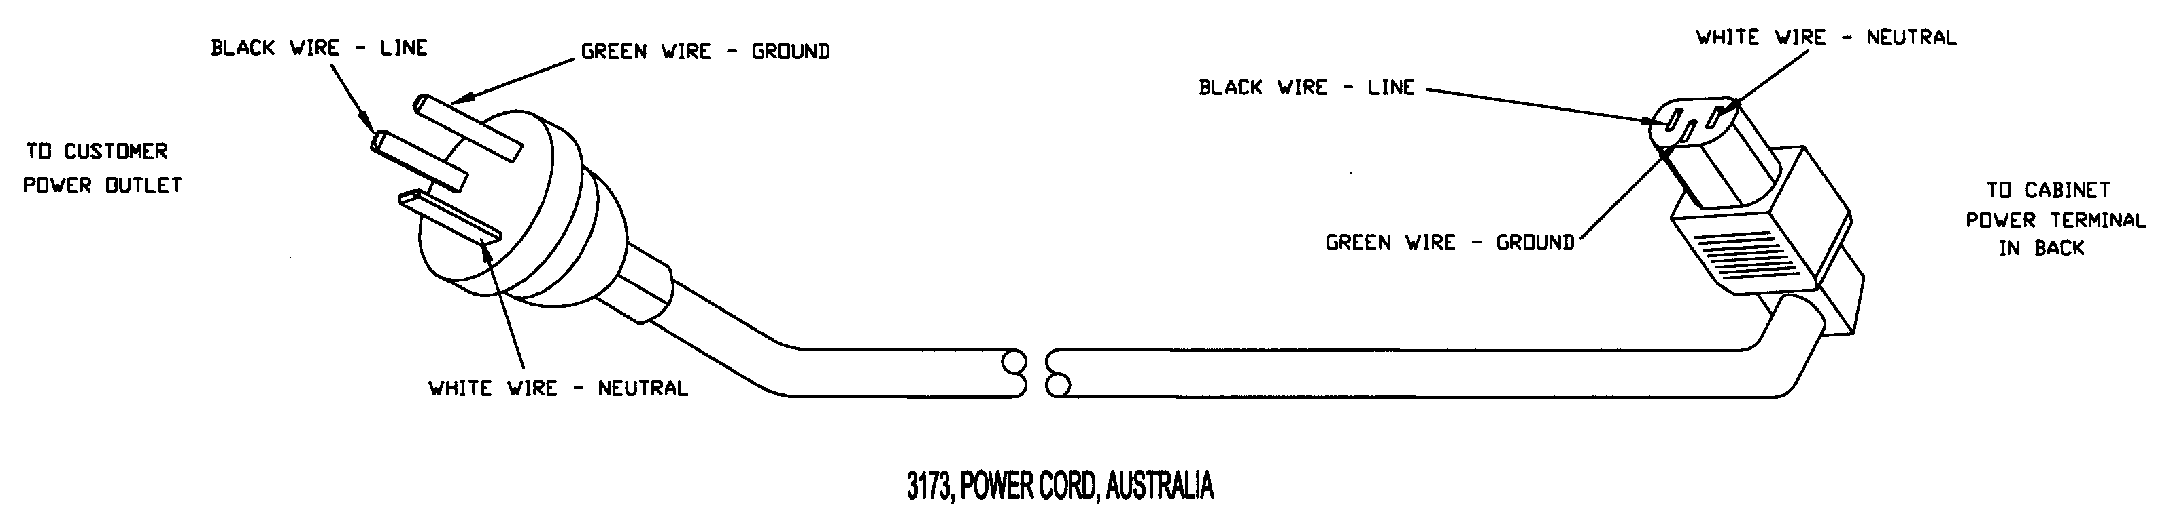
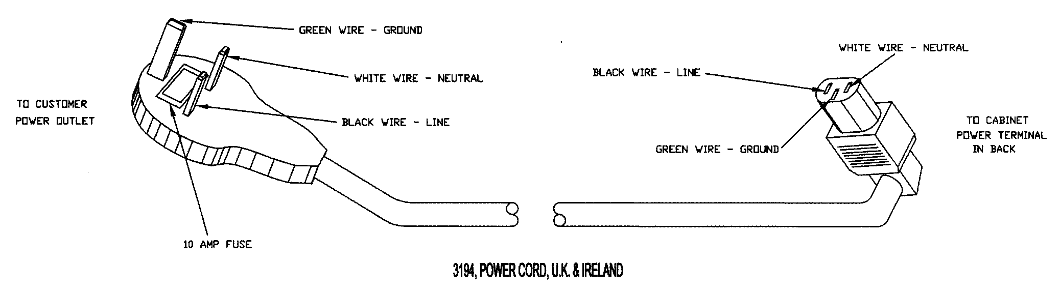

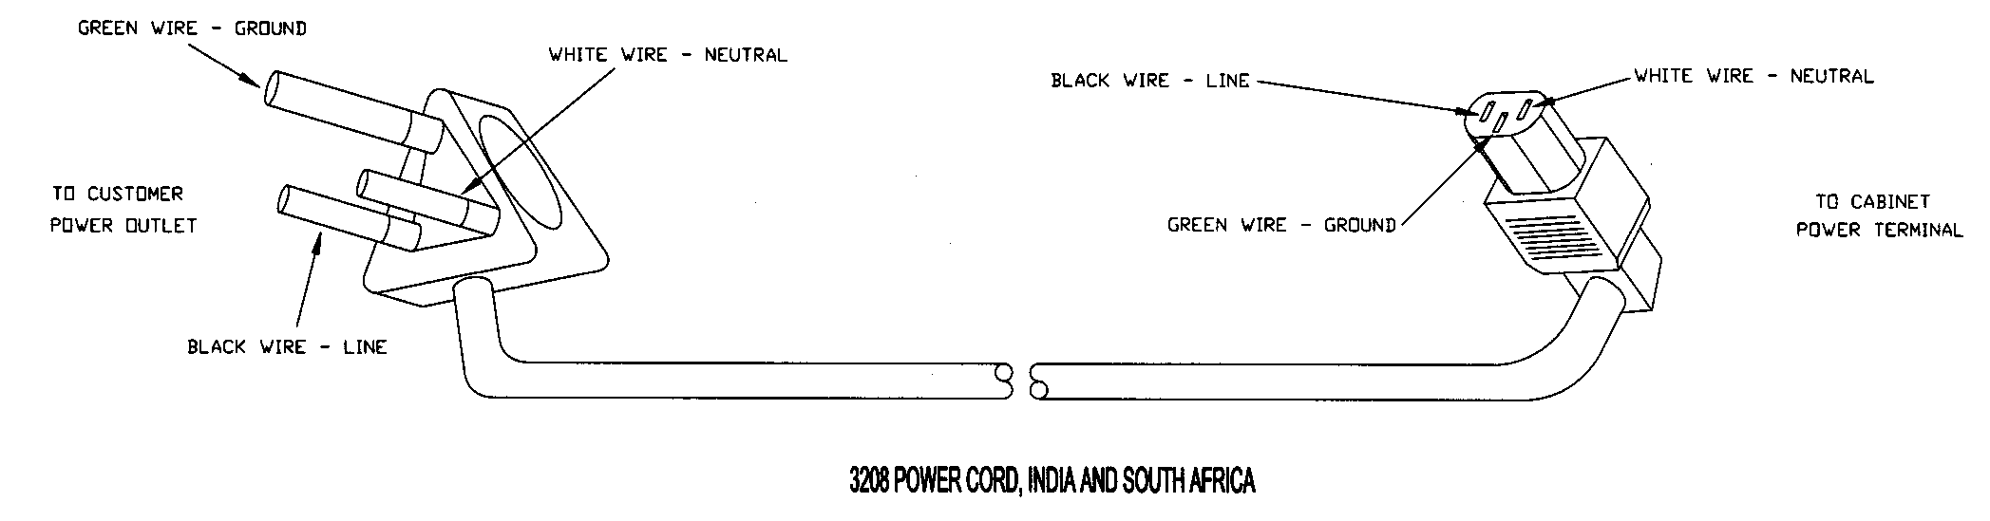

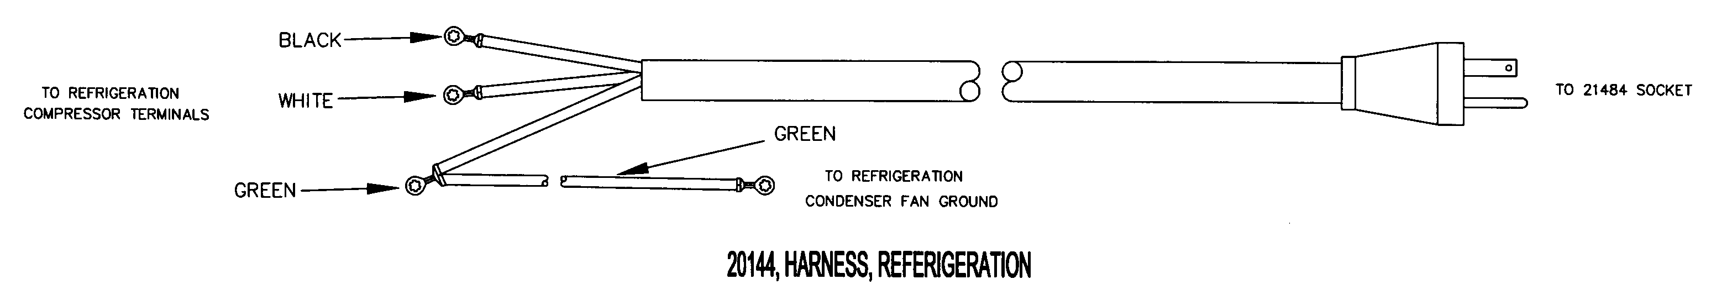

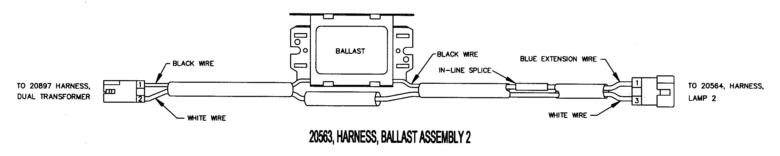

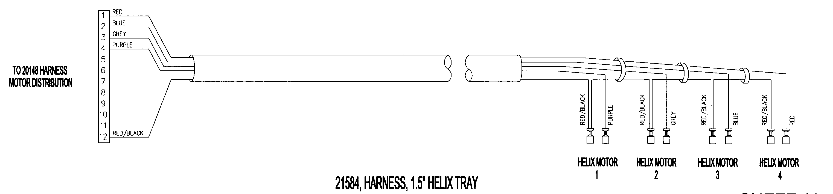

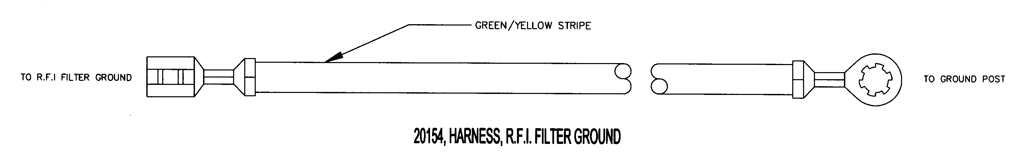

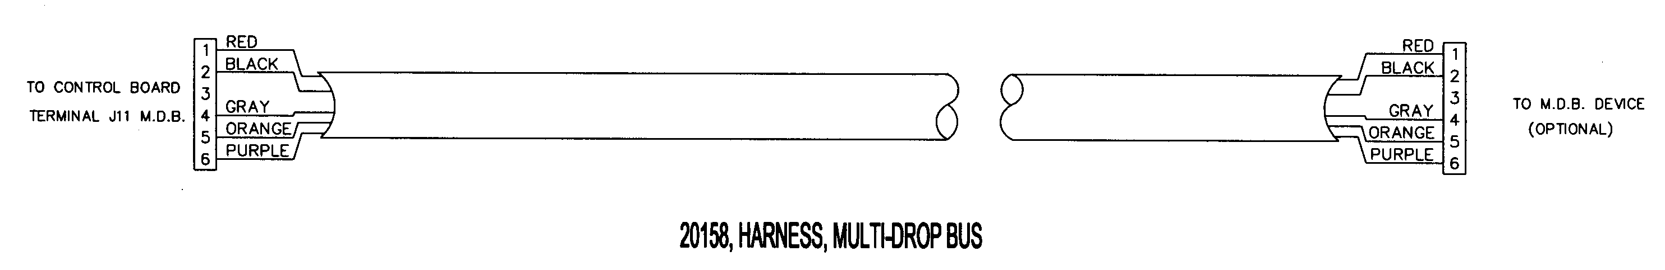



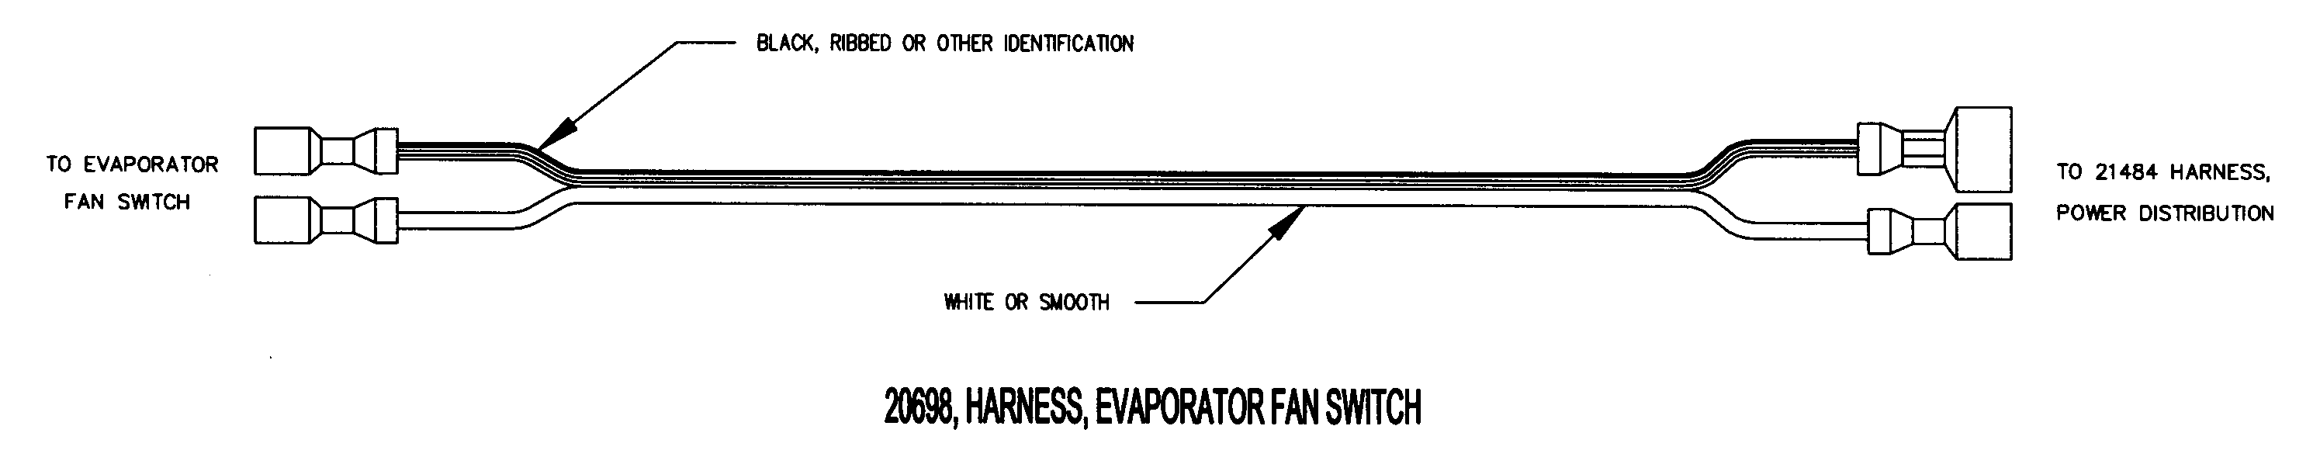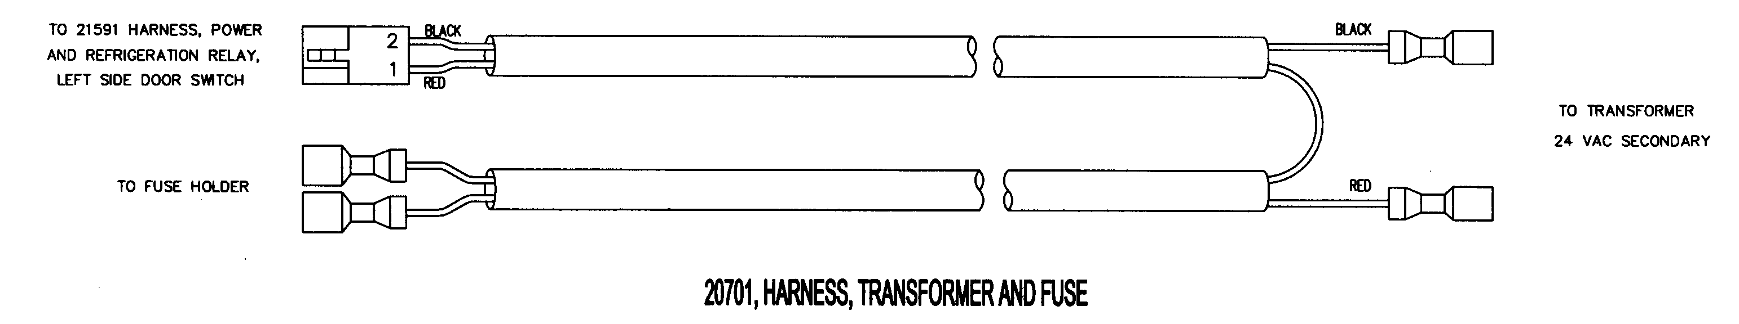

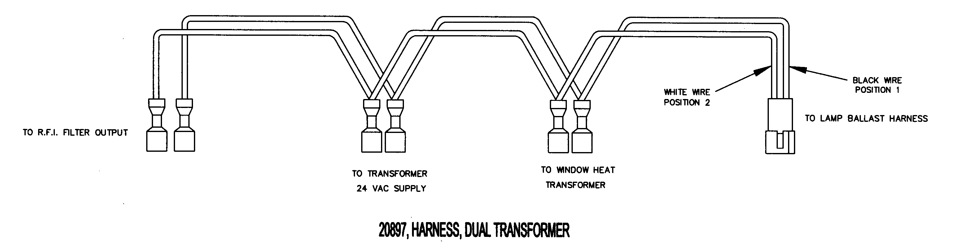

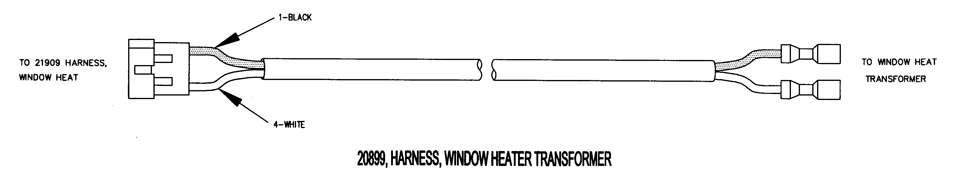

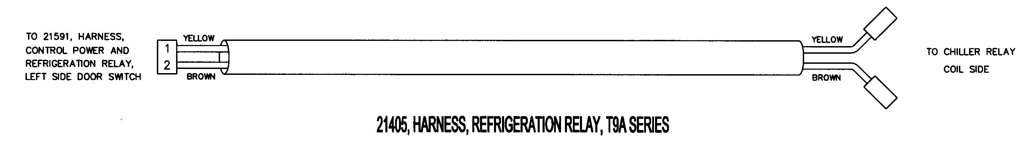

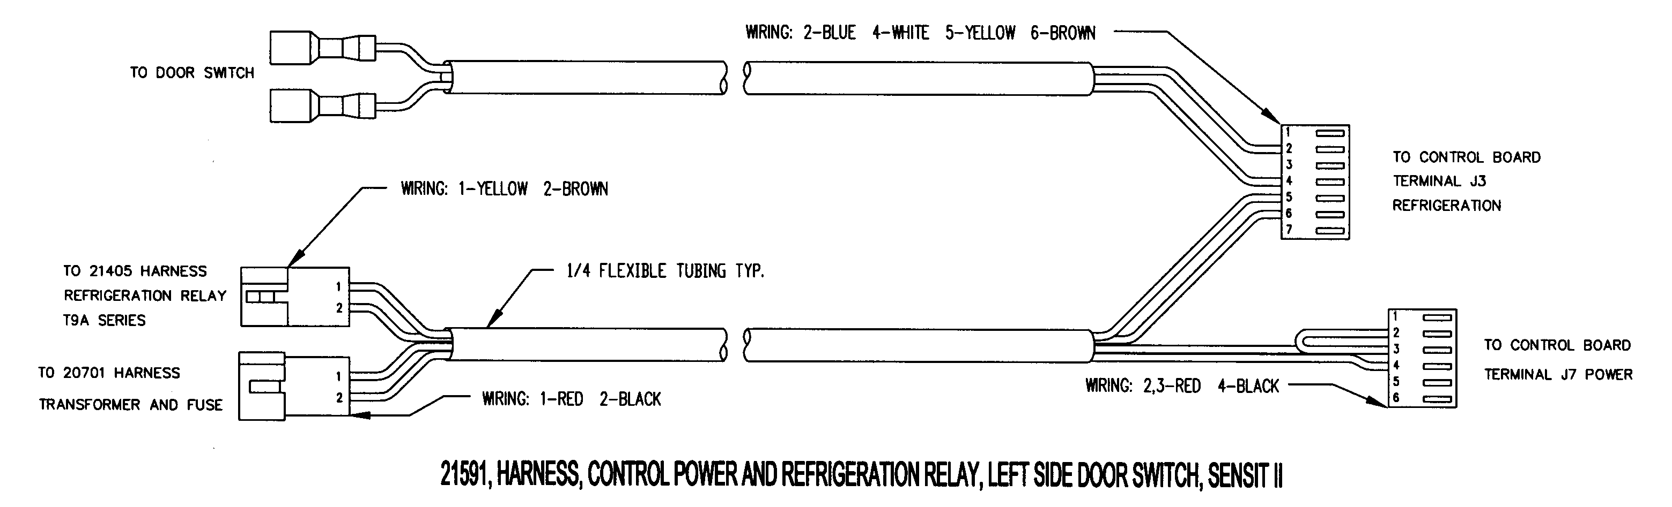
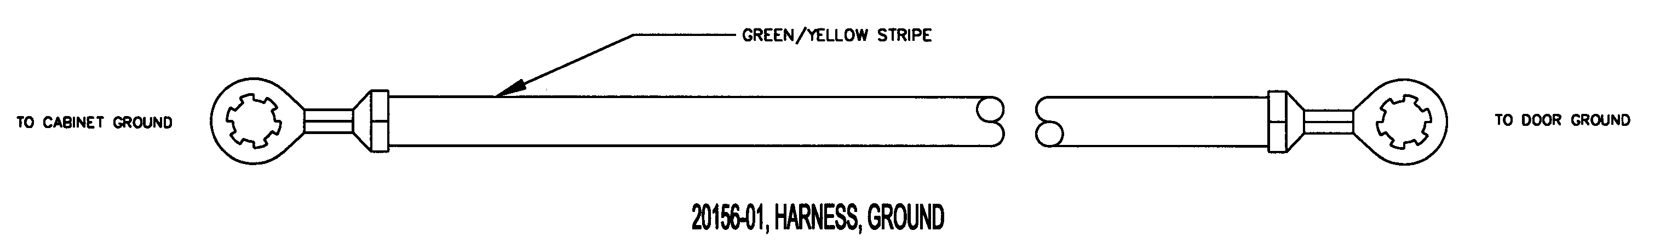

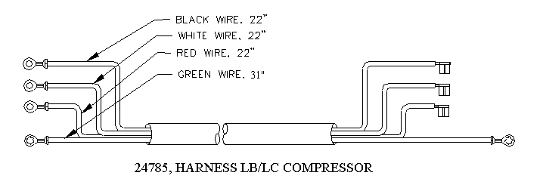

ELECTRICAL HARNESS PARTS LIST
PART NO. | PART DESCRIPTION | NOTES
22402 | POWER CORD ASSEMBLY, 115V U.S. & CANADA
3173 | POWER CORD, AUSTRALIA
3194 | POWER CORD, U.K. & IRELAND
3208 | POWER CORD, INDIA & SOUTH AFRICA
20144 | REFRIGERATION HARNESS
20146 | DOOR MOTORS HARNESS
20147 | 10 COLUMN TRAY HARNESS
20148 | MOTOR DISTRIBUTION HARNESS
20154 | RFI FILTER GROUND
20158 | MULT-DROP BUSS HARNESS
20563 | BALLAST ASSEMBLY | OPTIONAL LIGHTING ITEM
20698 | EVAPORATOR FAN HARNESS
20701 | TRANSFORMER AND FUSE HARNESS
20897 | DUAL TRANSFORMER HARNESS
20899 | WINDOW HEATER TRANSFORMER HARNESS | NOT ON LB5/LC5 MODELS
21405 | REFRIGERATION RELAY HARNESS
21425 | DELIVERY SENSOR HARNESS
21426 | DELIVERY SENSOR DETECTOR/EMITTER HARNESS
21427 | PRODUCT SENSOR EMITTER HARNESS
21428 | PRODUCT SENSOR DETECTOR | OPTIONAL ITEM
21978 | HARNESS, GROUNG, EMITTER/DETECTOR
24015 | DISPLAY HARNESS
21468 | TEMPERATURE SENSOR
21484 | POWER DISTRIBUTION HARNESS | VCB/VCF MODELS
21485 | ON/OFF SWITCH HARNESS
21584 | 1.5”HELIX TRAY HARNESS
21591 | CONTROL POWER AND REFRIGERATION HARNESS
24617 | WINDOW HEATER HARNESS | NOT ON LB5/LC5 MODELS
20156-01 | GROUND HARNESS
22470 | CONDENSER FAN HARNESS (LB/LC MODELS)
23625 | DUAL TRANSFORMER, NO BALLAST HARNESS
22469 | EVAPORATOR FAN HARNESS (LB/LC MODELS)
24785 | HARNESS, LB/LC COMPRESSOR
22462 | RELAY, CAPACITOR HARNESS
22653 | REFRIGERATION HARNESS (LB/LC MODELS)
22815 | POWER DISTRIBUTION HARNESS (LB/LC MODELS)
24338 | LIGHTED POS POWER HARNESS

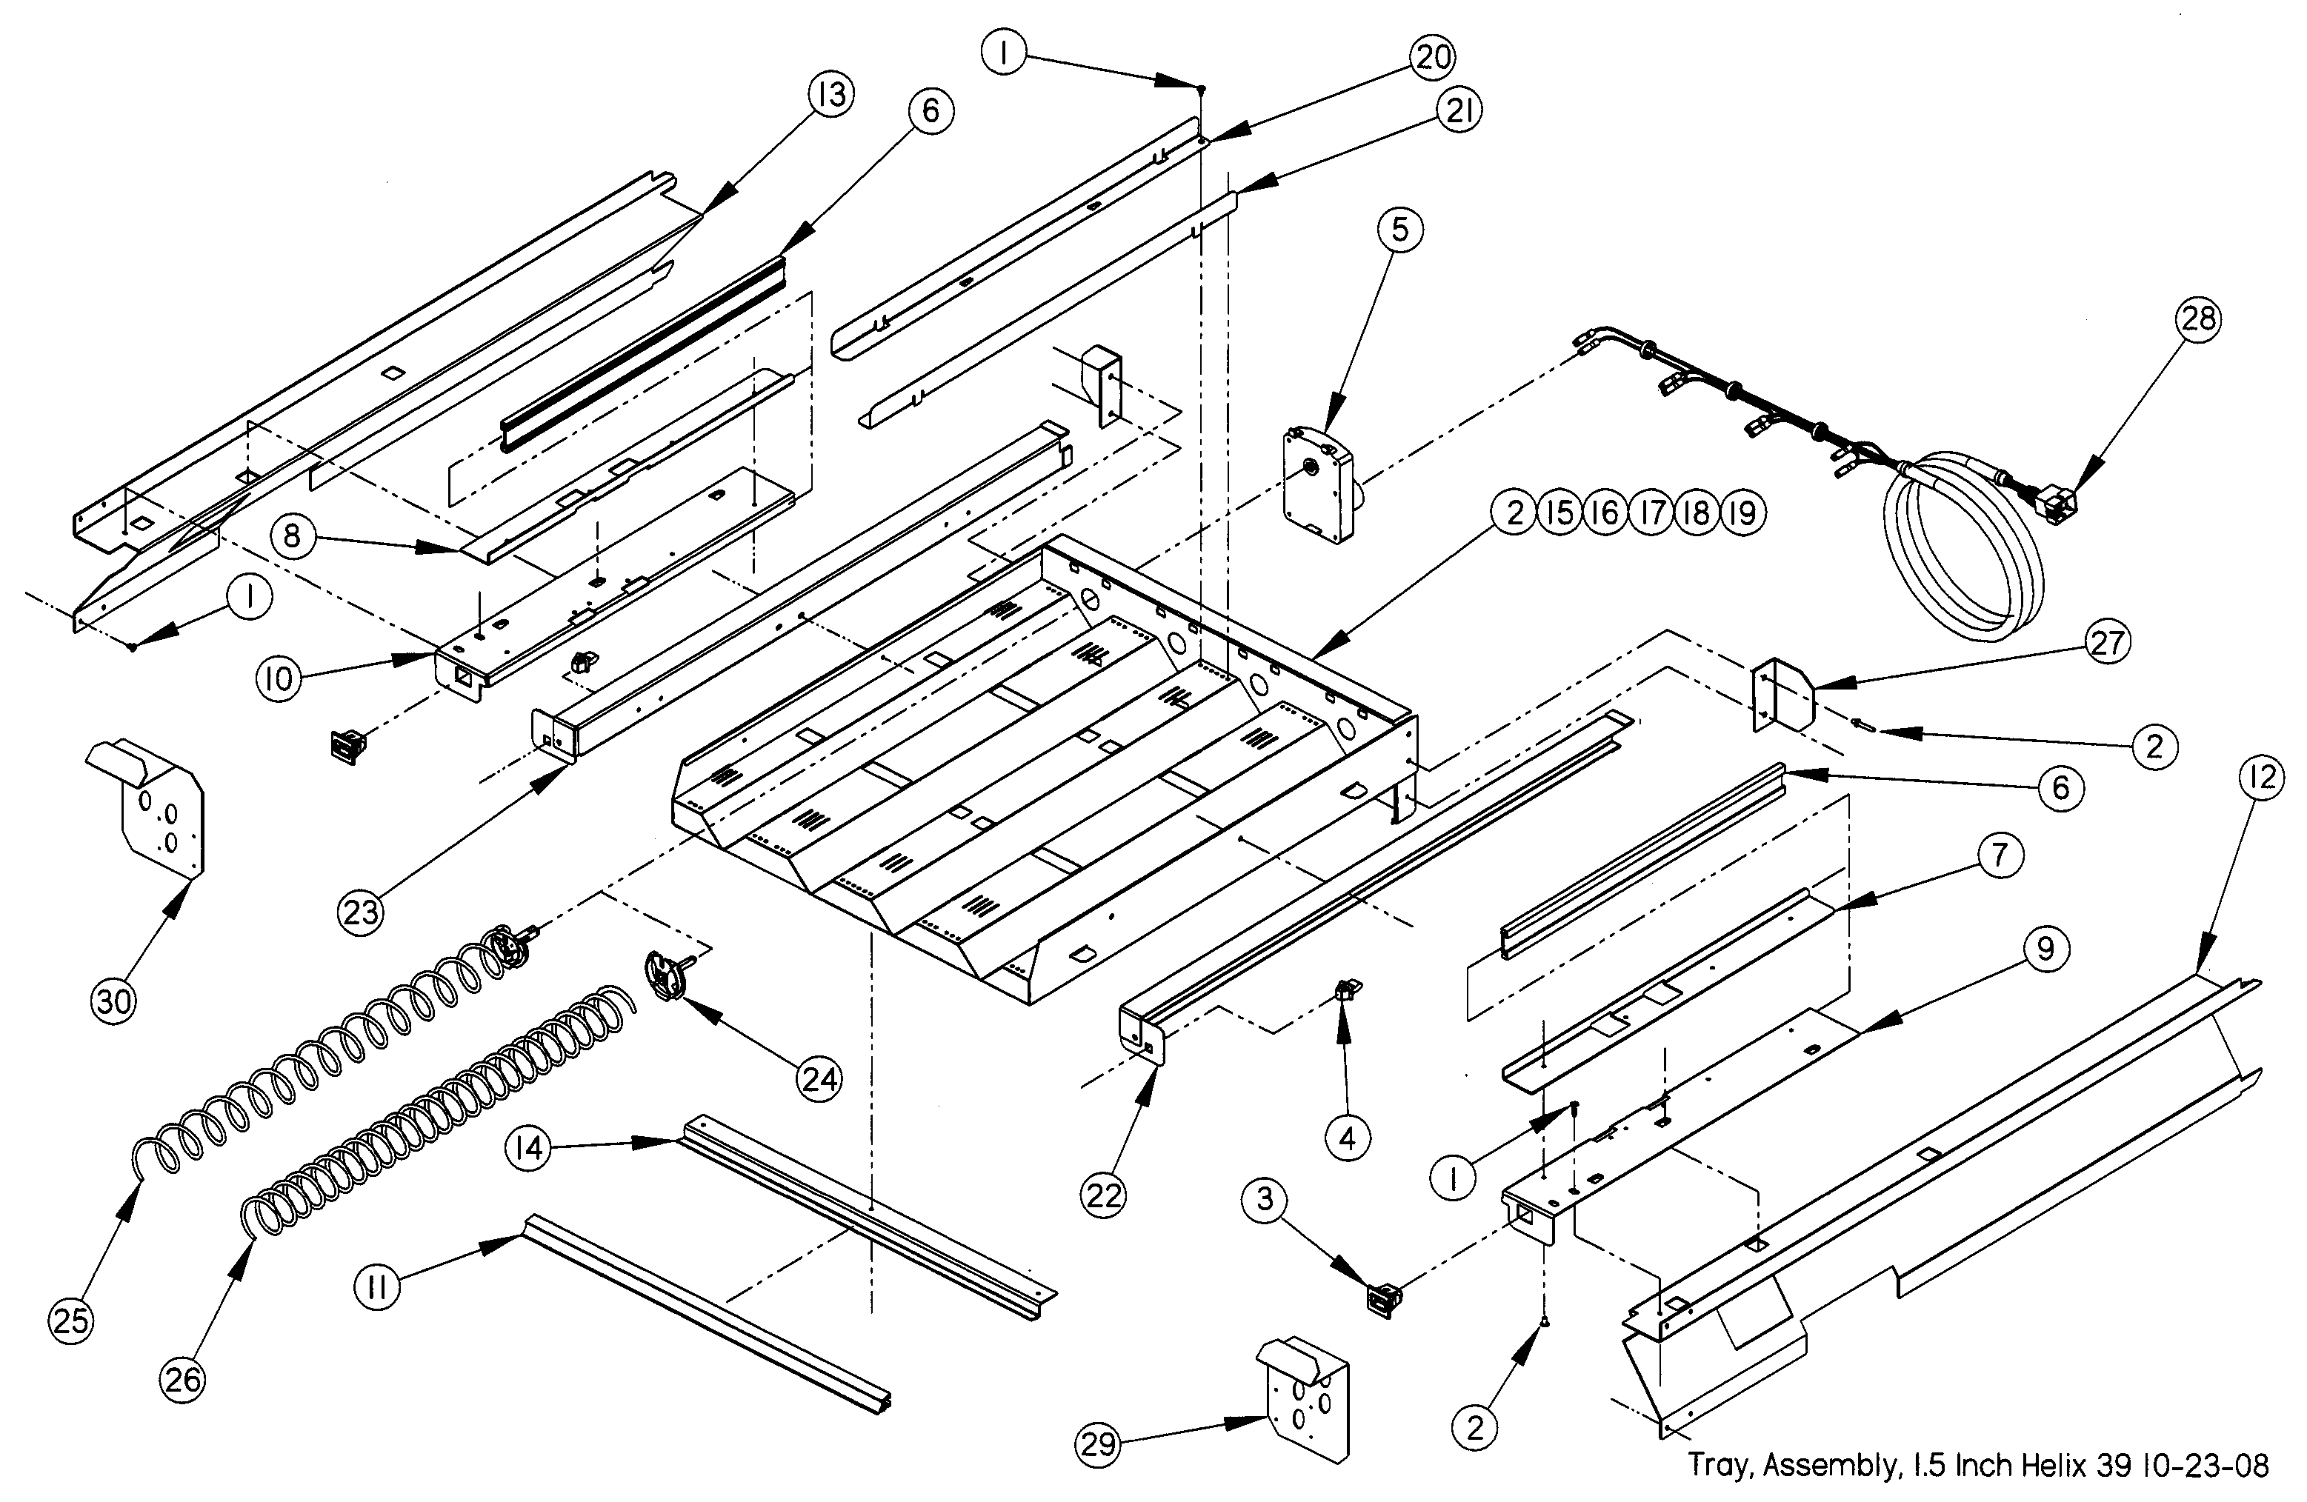
1.5” HELIX TRAY ILLUSTRATION

1.5” HELIX TRAY ASSEMBLY PARTS LIST
ITEM NO | PART NO. | PART NAME | QTY | NOTES
1 | 3000 | Screw, TEK 8-18 | 18
2 | 3009-02 | Rivet, Pop, Steel, 1/8 | 34
3 | 3246 | Latch, Nylon, Gum and Mint | 2
4 | 3247 | Strike, Nylon, Gum and Mint | 2
5 | 23007 | Motor, w/Home Circuit | 4
6 | 20236 | Extrusion, Gum and Mint Rail | 2
7 | 20237 | Extrusion Mount, Upper (Gum and Mint)(Right Side) | 1
8 | 20237-01 | Extrusion Mount, Upper (Gum and Mint)(Left Side) | 1
9 | 20238 | Extrusion Mount, Lower (Gum and Mint)(Right Side) | 1
10 | 20238-01 | Extrusion Mount, Lower (Gum and Mint)(Left Side) | 1
11 | 20465-04 | Extrusion, Price Marker, Reduced Height | 1
12 | 20973 | Rail, Gum and Mint, Reduced Depth (39”)(Right Side) | 1 | Rails To Fit Tray To 39” Cabinet
13 | 20973-01 | Rail, Gum and Mint, Reduced Depth (39”)(Left Side) | 1 | Rails To Fit Tray To 39” Cabinet
14 | 21196 | Doubler, Tray 1.5” Helix Tray | 1
15 | 21197 | Tray Body, 1.5” Helix Tray | 1 | Parts Are Factory Assembled As A Unit
16 | 21199 | Tray Back, 1.5” Helix Tray | 1 | Parts Are Factory Assembled As A Unit
17 | 21200 | Tray Inner Side, 1.5” Helix Tray | 2 | Parts Are Factory Assembled As A Unit
18 | 21201 | Tray Inner Section, 1.5” Helix Tray | 2 | Parts Are Factory Assembled As A Unit
19 | 21202 | Tray Inner Mid Section, 1.5” Helix Tray | 1 | Parts Are Factory Assembled As A Unit
20 | 21203 | Divider, Tray, 1.5” Helix Tray, RH | 4
21 | 21203-01 | Divider, Tray, 1.5” Helix Tray, LH | 4
22 | 21204 | Tray Slide Channel,1.5” Helix Tray, RH | 1
23 | 21204-01 | Tray Slide Channel,1.5” Helix Tray, LH | 1
24 | 21206 | Helix Adapter, 1.5” Helix Tray | 4
25 | 21207-15 | Helix, 1.5” Tray, Counterclockwise, Black | 2 | Tray is Equipped With Two Of Each
26 | 21207-25 | Helix, 1.5” Tray, Counterclockwise, Black | 2 | Tray is Equipped With Two Of Each
27 | 21523 | Bracket, Stop, 1.5” Helix Tray | 2
28 | 21584 | Harness, 1.5” Helix Tray | 1
29 | 22387 | Deflector Plate, 1.5” Helix Tray, 1-1/2 CF. Hopper (39”) | 1 | RH, Mount On Hopper For 1.5 Tray Only
30 | 22387-01 | Deflector Plate, 1.5” Helix Tray, 1-1/2 CF. Hopper (39”) | 1 | LH, Mount On Hopper For 1.5 Tray Only

General Note: The 1.5 Helix Tray has replaced the 20668 Gum and Mint Tray.
BOTTLE TRAY ILLUSTRATION

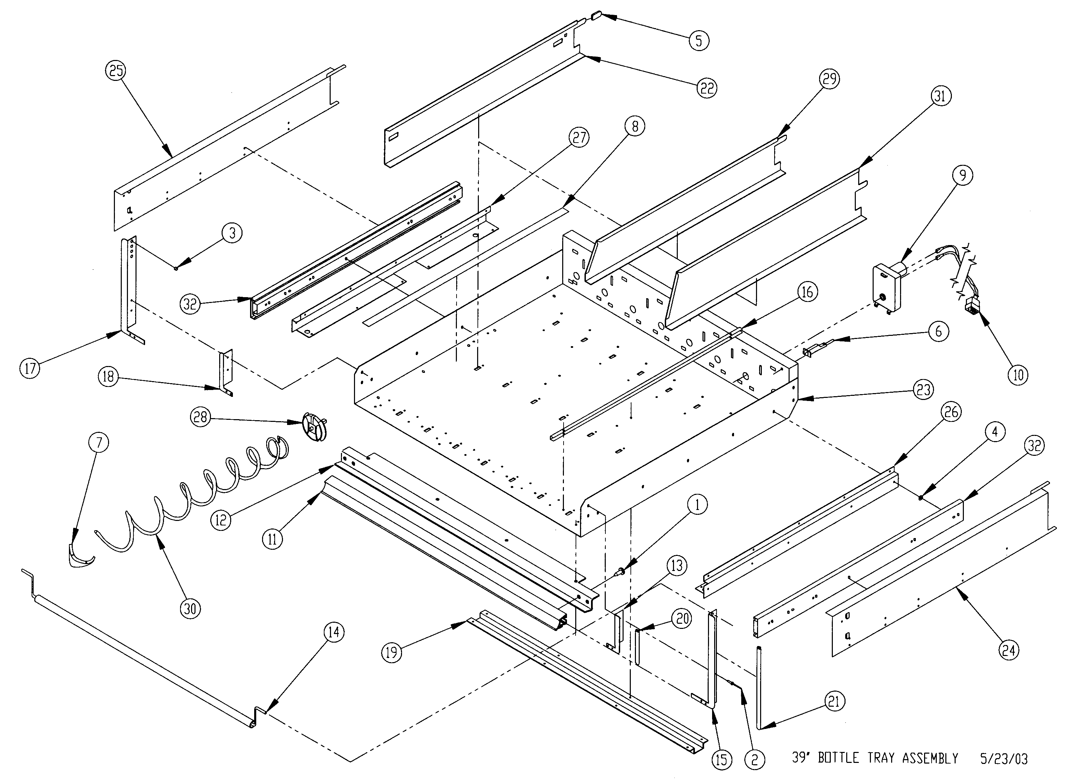

BOTTLE TRAY PARTS LIST
ITEM | PART NO | PART DESCRIPTION | NOTE
1 | 3001-03 | Screw, Sheet Metal, Type B, 8-18
2 | 3009-02 | Rivet, Pop, Steel, 1/8
3 | 3015 | Bearing, Nyliner, Snap-In | Use On 20691 And 20724 for Bottle Tipper
4 | 3017-05 | Washer, Flat Steel
5 | 3021 | Protective Cap, Vinyl | Obsolete Part
6 | 3042-01 | Wire Tie, Panel Mount
7 | 3111 | Helix Ejector, Small Helix
8 | 3189-01 | Tape, UHMW Polyethylene, 3/4” X .005”
9 | 20086 | Motor, Single Helix W/O Switch
10 | 20147 | Harness, Tray, 8 Column
11 | 20465-03 | Extrusion, Price Marker, Ver. 2
12 | 20644 | Tray Doubler, Bottle (39”)
13 | 20672 | Tray Corner, Bottle, Right | Use With 20690 Without Bottle Tipper
14 | 20690 | Assembly, Bottle Tipper Bar
15 | 20691 | Tray Corner, Bottle Tipper Bar, Right | Use With 20690 For Bottle Tipper
16 | 20692 | Device, Bottle Alignment
17 | 20724 | Tray Corner, Bottle Tipper Bar, Left | Use With 20690 For Bottle Tipper
18 | 20725 | Tray Corner, Bottle, Left | Use With 20690 Without Bottle Tipper
19 | 20775 | Tray Reinforcement, Bottle (39”) Ver. 2
20 | 20796-01 | Edge Guard, Tray Corner (Only RH) | Use On 20672 Without Bottle Tipper
21 | 20796-02 | Edge Guard, Tray Corner (Only RH) | Use On 20691 For Bottle Tipper
22 | 20956 | Tray Divider, Reduced Depth (Square Front) | 3.37” High (Optional Part)
23 | 20960 | Tray Body, Bottle, Reduced Depth (39”')
24 | 20980 | Rail, Bottle Tray, Reduced Depth (RH)
25 | 20980-01 | Rail, Bottle Tray, Reduced Depth (LH)
26 | 20962 | Bracket, Bottle Tray Rail, Reduced Depth (RH)
27 | 20962-01 | Bracket, Bottle Tray Rail, Reduced Depth (LH)
28 | 20966 | Helix Adapter, Without Hub
29 | 21276 | Tray Divider, Reduced Depth, Tapered Front | 3.37” High
30 | 21336 | Helix, 3” Counter-Clockwise | See Helix Description Section For Options.
31 | 21374 | Tray Divider, Reduced Depth, Tapered Front, High | 4.9” High (Optional Part)
32 | 21475-02 | Rail Slide, Full Extension, 24” | 1 Pair

SNACK/CANDY/FOOD TRAY ILLUSTRATION

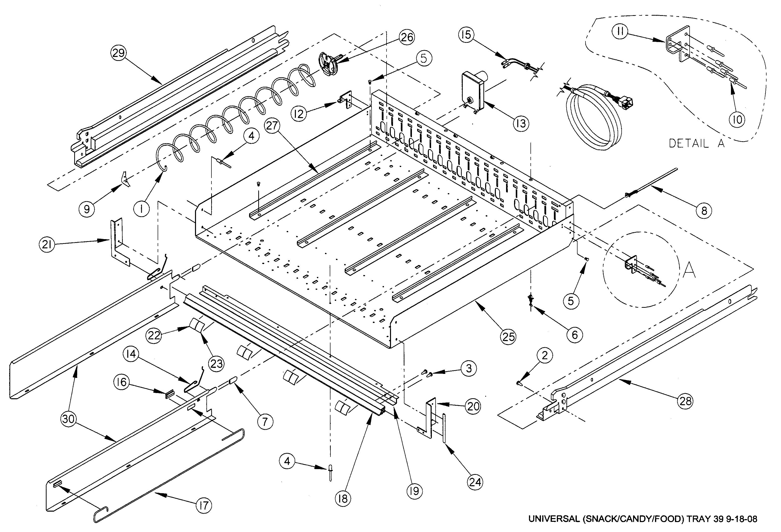
ITEM NO | PART NO. | PART DESCRIPTION | NOTE
1 | ------ | Helix | 1 Per Column - See Helix Section.
2 | 3000 | Screw, Sheet Metal, 8-18 | Safety Screws for Rails
3 | 3001-03 | Screw, Sheet Metal, Type B, #8-18 (3/8" Long)
4 | 3009-02 | Rivet, Pop, Steel, 1/8 (1/8" Grip)
5 | 3019 | Canoe Clip | 2 Per Helix Alignment Device
6 | 3020 | Wire Tie, Standoff
7 | 3021 | Divider Cap | Obsolete Part
8 | 3042-01 | Wire Tie, Panel Mount
9 | 3111 | Helix Ejector
10 | 3295-03 | Rivet, Steel, 1/8”, Plated | Use for Tray Stop
11 | 20073 | Tray Stop (Rh)
12 | 20073-01 | Tray Stop (Lh)
13 | 23007 | Motor, With Home Circuit | CCW
13 | 23007-01 | Motor, With Home Circuit | CW
14 | 20133 | Tray Divider Spring | Per Divider
15 | 20147 | Harness, Tray, 10 Column
16 | 20220 | Extrusion, Candy Pusher | Per Divider With Cut-outs
17 | 20221 | Bar, Candy Pusher | Per Divider With Cut-outs
18 | 20465-01 | Extrusion, Price Marker, Reduced Height
19 | 20544 | Tray Doubler, VER 2 (39”)
20 | 20545 | Tray Corner, Ver. 2 (Rh)
21 | 20545-01 | Tray Corner, Ver. 2 (Lh)
22 | 22909 | Label Sheet, Reduced Height Location
23 | 20614 | Label Sheet, Reduced Height Price
24 | 20796-01 | Edge Trim, Tray Corner | Right Hand Corner Only
25 | 20955 | Tray Body, Reduced Depth (39”)
25 | 21045 | Tray Body, Reduced Depth (35”)
26 | 20966 | Helix Adapter, Without Hub
27 | 22192 | Helix Alignment Device, PVC
28 | 22250 | Assembly, Rail, Snack, Right
29 | 22251 | Assembly, Rail, Snack, Left
30 | 23333 | Tray Divider, VER 2, 3-3/8” High | Select Type, Numbers To Form Columns
30 | 23334 | Tray Divider, VER 2, 4-7/8” | Select Type, Numbers To Form Columns
SNACK/CANDY/FOOD TRAY PARTS LIST
SCROLLING PRICE TRAY ILLUSTRATION

SCROLLING PRICE TRAY PARTS LIST
ITEM | PART NO. | PART DESCRIPTION | NOTE
1 | 20073 | TRAY STOP
2 | 20073-01 | TRAY STOP LEFT
3 | 23007 | MOTOR, COUNTER CLOCKWISE
3 | 23007-01 | MOTOR, CLOCKWISE | OPTIONAL
4 | ------------ | HELIX | SEE HELIX TABLE
5 | 20147 | HARNESS, TRAY 10 COLUMN
6 | 20220 | EXTRUSION, CANDY PUSHER | OPTIONAL
7 | 20021 | BAR, CANDY PUSHER | OPTIONAL
8 | 20545 | TRAY CORNER, RH
9 | 20545-01 | TRAY CORNER, LH
10 | 20796-01 | EDGE TRIM, TRAY CORNER | RIGHT HAND SIDE ONLY
11 | 20955 | TRAY BODY (39”)
11 | 21045 | TRAY BODY (35”)
12 | 20966 | HELIX ADAPTOR
13 | 21138 | DIVIDER, STANDARD, 3 3/8” High
13 | 21139 | DIVIDER, HIGH, 4 7/8” High | OPTIONAL
13 | 23664 | DIVIDER, EXTRA HIGH, 8” High | OPTIONAL
14 | 22192 | HELIX ALIGNMENT DEVICE | OPTIONAL
15 | 23322 | SCROLL, PRICE LABEL, 1-20
15 | 23321 | SCROLL, PRICE LABEL, .00-.95
16 | 23785 | TRAY STIFFENER
17 | 23786 | TRAY STIFFENER COVER
18 | 23787 | GUIDE
19 | 23791 | 10 SELECT COVER
19 | 23791-01 | 10 SELECT COVER, NO WINDOWS | OPTIONAL, FOR DUAL HELIX SELECTION
20 | 3000 | SCREW
21 | 3009-02 | RIVET
22 | 3019 | CANOE CLIP
23 | 3020 | WIRE TIE STANDOFF
24 | 3042-01 | WIRE TIE, PANEL MOUNT
25 | 3111 | HELIX EJECTOR
26 | 3295-03 | RIVET
27 | 23292 | LOCATION LABEL

HELIX ILLUSTRATIONS

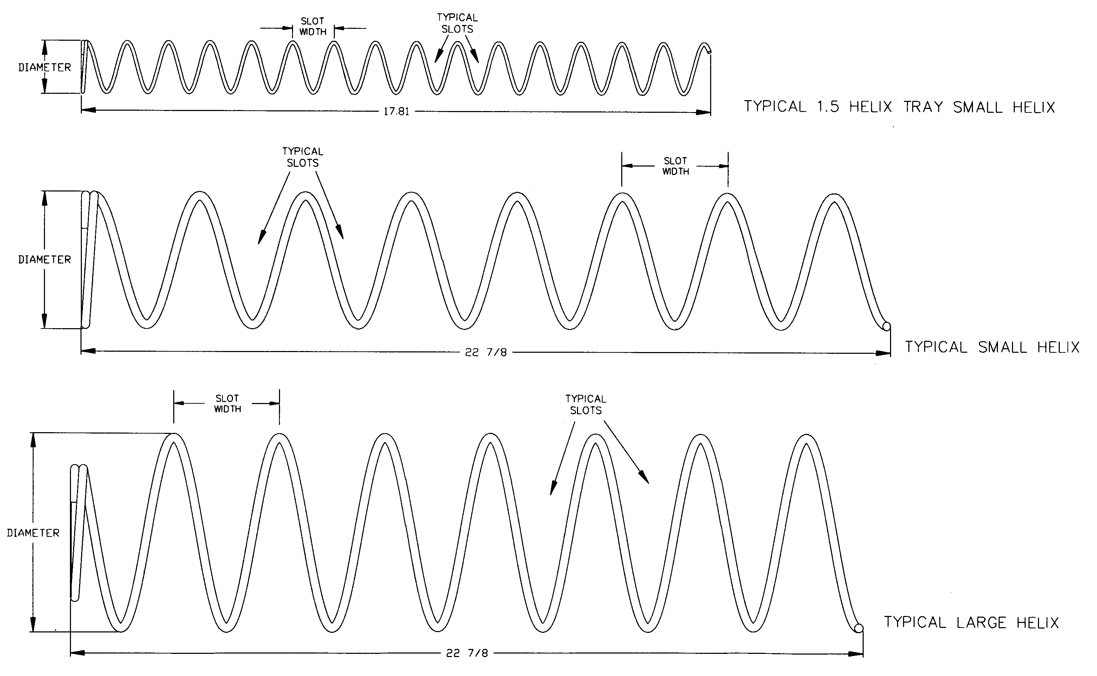

HELIX PARTS LIST
PART  NO. | HELIX DESCRIPTION * | SLOT  WIDTH | NUMBER OF SLOTS  (PITCH) | HELIX  OUTSIDE  DIAMETER | TURNS | NOTE
20119-07 | Helix, Small CW, Black | 2 5/8 | 7 | 2.6 | CW | Use With 20120-07 As A Set
20120-07 | Helix, Small CCW, Black | 2 5/8 | 7 | 2.6 | CCW
20119-10 | Helix, Small CW, Black | 1 7/8 | 10 | 2.6 | CW | Use With 20120-10 As A Set
20120-10 | Helix, Small CCW, Black | 1 7/8 | 10 | 2.6 | CCW
20120-12 | Helix, Small CCW, Black | 1 7/8 | 12 | 2.6 | CCW
20120-15 | Helix, Small CCW, Black | 1 7/8 | 15 | 2.6 | CCW
20120-18 | Helix, Small CCW, Black | 1 7/8 | 18 | 2.6 | CCW
20120-24 | Helix, Small CCW, Black | 1 7/8 | 24 | 2.6 | CCW
21207-15 | Helix, 1.5”, CCW, Black | 1 | 15 | 1.5 | CCW | Use in 1.5” Helix Tray
21207-25 | Helix, 1.5”, CCW, Black | 9/16 | 25 | 1.5 | CCW | Use in 1.5” Helix Tray
21336 | Helix, 3”, CCW, Black | 3.5 | 6 | 3 | CCW | Bottle Tray
21337 | Helix, 3”, CCW, Black | 3.2 | 6 | 3 | CCW | Bottle Tray
21465-5 | Helix, 3.75” CCW, Black | 3 ¼ | 5 | 3.75 | CCW | Large
21465-7 | Helix, 3.75” CCW, Black | 2 5/8 | 7 | 3.75 | CCW | Large
21465-9 | Helix, 3.75” CCW, Black | 2 | 9 | 3.75 | CCW | Large
21465-10 | Helix, 3.75” CCW, Black | 1 ¾ | 10 | 3.75 | CCW | Large
21465-12 | Helix, 3.75” CCW, Black | 1 ½ | 12 | 3.75 | CCW | Large
21465-15 | Helix, 3.75” CCW, Black | 1 ¼ | 15 | 3.75 | CCW | Large
General Note: Please call AMS if a helix with a special pitch is required. Also, the quantity of helixes required depends on the vendor configuration.

