 | 

MODEL 28 and 39 GEM

GLASS FRONT MERCHANDISER
ILLUSTRATED PARTS MANUAL

L0125, REV. E
 | AUTOMATED MERCHANDISING SYSTEMS INC  255 WEST BURR BLVD.  KEARNEYSVILLE, WV 25430  304-725-6921 - Fax 304-725-6983  info@amsvendors.com  www.amsvendors.com | INTERNATIONAL A.M.S. S DE RL DE CV  KM. 9 CARR. AL CASTILLO NO. 8200  MPIO. DE EL SALTO, JAL. MEXICO 45680  5233-3-6-88-07-17 - Fax 5233-3-6-88-13-14  www.amsint.com.mx  servicio@amsint.com.mx

AMS Glass Front Merchandiser
Model 28 and 39 GEM
Illustrated Parts Manual

Table of Contents
SECTION PAGE
INTRODUCTION
Table of Contents 3
General Introduction 4
Manual Organization 4
Merchandiser Identification 5
Patent Disclosure 6
Publication Notice 6

CABINET DOOR 8

HOPPER 12

CABINET 16

BASE PLATE 20

CONTROL BAY DOOR 22

RIGHT RAIL MOUNT 26

LEFT RAIL MOUNT/ LIGHTING 30

TRAYS AND PARTS 32

ELECTRICAL HARNESSES 48

HELIXES 60

GENERAL INTRODUCTION

The purpose of this manual is to give our customers a way of identifying major service parts for repair and replacement. The illustrations and parts list in this manual are for identification only. Some optional parts are also shown.

Illustrations of these major parts are keyed with our part numbers. The illustrations help identify the general design, position and orientation of these parts. The note section may also give important information.

Please refer to the section on merchandiser identification on the following pages. Without the model style and serial number it may be difficult to identify the required part.

Parts should be ordered from your distributor.

It is our intent to assist our customers with up-to-date documentation. However, this manual may not show all parts, variations or changes. Some parts may be shown out of scale. This manual is itself subject to change without notice. If any errors are found, please notify AMS so the correction can be included in later revisions. Engineering data and third party information are generally not included. The graphical data, group assembly data, parts, part assembly, parts breakout information and tabular data conveyed by this manual is proprietary and belongs to AMS, and holders without prior consent of or without knowledge of and by AMS must surrender this data immediately.

All measurements are in inches except where specified as Metric.

MANUAL ORGANIZATION

This manual is divided into general sections. Each section is further divided into the various subsections or subassemblies. These lead off with one or more illustrations showing the parts and each part is identified with a number. Note that some part numbers are for assemblies fabricated as a unit at AMS and are replaceable only as a unit. Also, other part numbers identify optional parts which may or may not have been contracted for and factory installed by AMS.

The part number in the illustration is listed with the description or title for that part. In some instances there may be multiple parts to choose from. The correct service or repair part for the style of merchandiser must be selected.
There is a note section where additional information may be found.

This manual contains additional and new information for a vendor as currently manufactured. Older revisions of this manual should be kept with older vendors.

MERCHANDISER IDENTIFICATION

When requesting service, replacement parts or technical assistance, please use the Model Number and the Serial Number with Date Code, found on the Serial Plate (Refer to Figure 1) affixed to the merchandiser. The plate is usually located inside the window. The information contained on this plate is necessary to determine what parts, kits, or maintenance apply to your vendor.
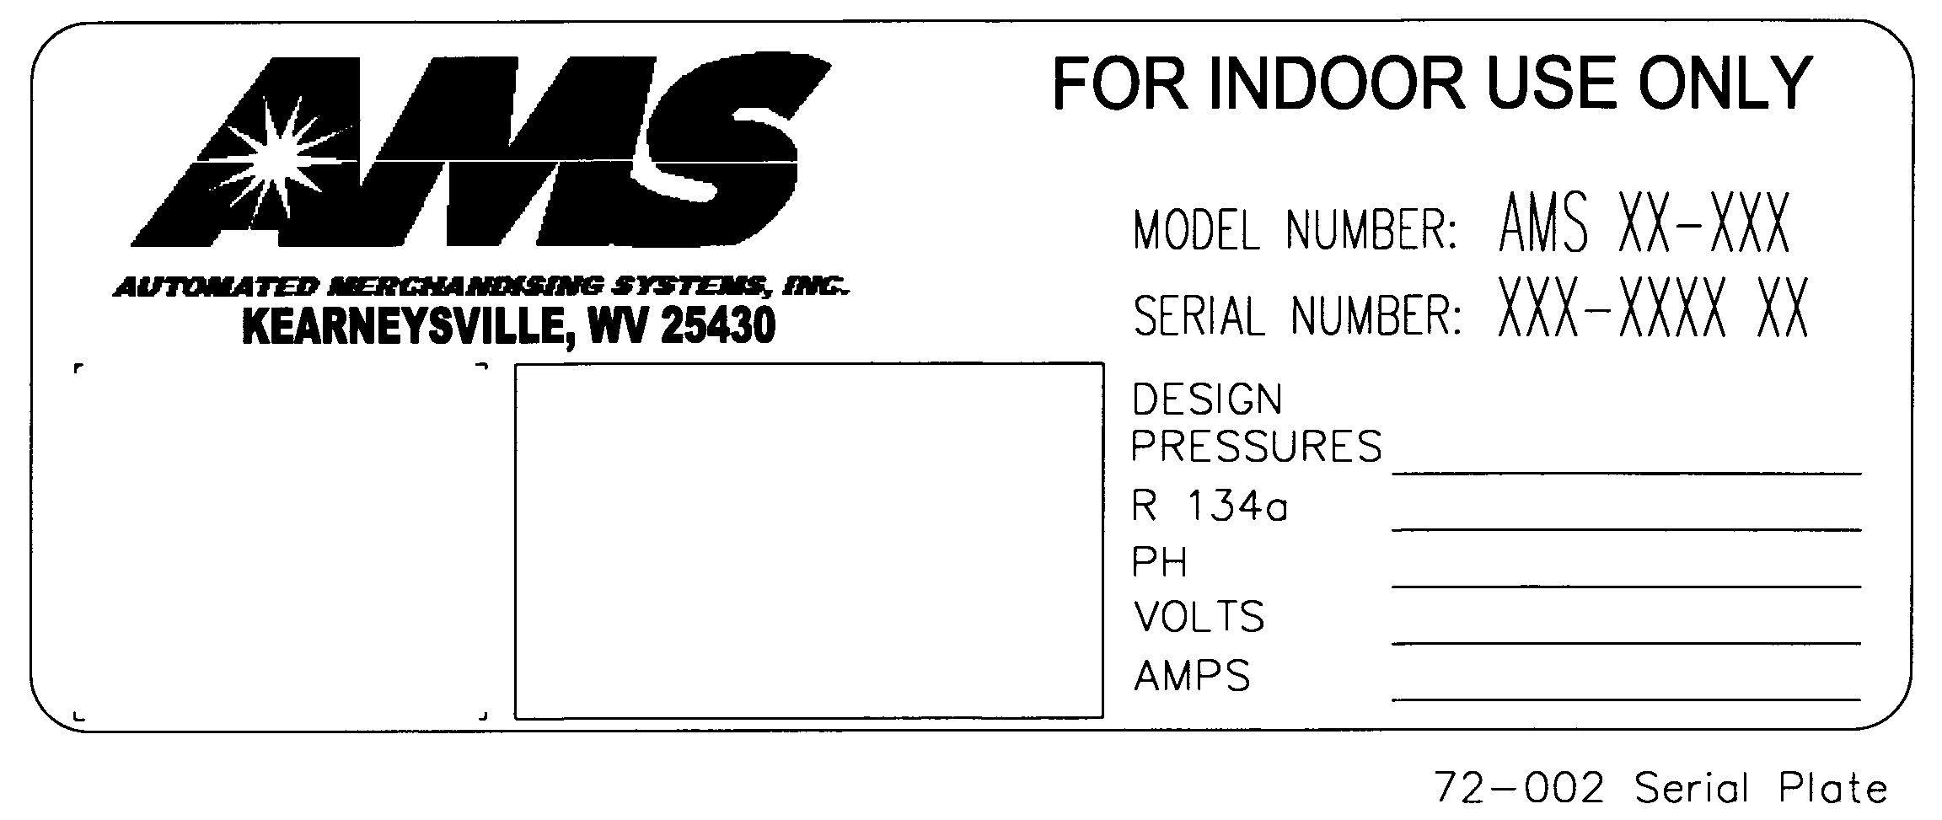
Figure 1. Example of Typical Serial Plate

Example of Model Number Breakdown  AMS G8 – 6 24  Manufacturer Cabinet Width No. of Trays No. of Selections  Example: AMSG8-6-24 means this vendor is an Automated Merchandising Systems merchandiser, 28” wide, with six (6) trays making available twenty four (24) positions for different products. | Example of Serial Number and Date Code Breakdown  1 - 0902 - 0275  Built Year Month Sequence  Example: 1-0902-0275 is translated as U.S. built (1), manufactured in 2009, month of February, and was the 275th manufactured that year.  Note: Manufactured in Mexico, Built = (2)

PATENT DISCLOSURE

This merchandiser and/or certain of its components are covered by one or more of the following U.S. and international patents;

U.S. PATENTS: 6,041,962; 6,145,699; 6,202,888; 6,384,402; 6,520,373; 6,708,079; 6,794,634; 7,191,915; 7,246,719; 7,343,220 B2; 7,742,837; 7,446,302; 8,003,931.

CANADIAN PATENT 2,329,314.

MEXICO PATENT 230714.

PUBLICATION NOTICE

L0125, Revision E, ECN 3113, 01/24/14

It is our intent to assist our customers with up-to-date documentation: however, this manual may not contain all updates and is subject to revision without notice. Please contact our Service Department with your requests or comments.

THIS PAGE INTENTIONALLY LEFT BLANK

CABINET DOOR ILLUSTRATION

CABINET DOOR PARTS LIST
ITEM | PART NO. | PART DESCRIPTION | NOTES
 | 25259 | CABINET DOOR 28” SLIM GEM (COMPLETE) | COLOR: BLACK
 | 25259-01 | CABINET DOOR 28” SLIM GEM (COMPLETE) | COLOR: RED
 | 25259-02 | CABINET DOOR 28” SLIM GEM (COMPLETE) | COLOR: BLUE
 | 25259-03 | CABINET DOOR 28” SLIM GEM (COMPLETE) | COLOR: GRAY
 | 25263 | CABINET DOOR 39” WIDE GEM (COMPLETE) | COLOR: BLACK
 | 25263-01 | CABINET DOOR 39” WIDE GEM (COMPLETE) | COLOR: RED
 | 25263-02 | CABINET DOOR 39” WIDE GEM (COMPLETE) | COLOR: BLUE
 | 25263-03 | CABINET DOOR 39” WIDE GEM (COMPLETE) | COLOR: GRAY
1 | 20131 | LOCK, T-HANDLE CYLINDER
2 | 21318-01 | DECAL, WARNING, NO TIP OR ROCK ENGLISH/SPANISH/FRENCH
3 | 21325 | DECAL, WARNING TRAY EXTENSION ENGLISH/SPANISH/FRENCH
4 | 23372-01 | TRIM, PLASTIC COIN CUP, GRAY
5 | 23373-01 | ASSEMBLY, PLASTIC COIN CUP, GRAY
6 | 23865 | GLASS, SINGLE PANE, 28” SLIM VENDOR | MODEL 28” SLIM
6 | 24164 | GLASS, SINGLE PANE, 39” GEM | MODEL 39” WIDE
7 | 23871 | ASSEMBLY, DOOR FRAME, WELDMENT, 28” SLIM | MODEL 28” SLIM
7 | 24163 | ASSEMBLY, DOOR FRAME, WELDMENT, 39” GEM | MODEL 39” WIDE
8 | 23873 | ASSEMBLY, HOPPER, 28” SLIM VENDOR | MODEL 28” SLIM
8 | 24170 | ASSEMBLY, HOPPER, 39” GEM | MODEL 39” WIDE
9 | 23875 | BRACE, DOOR KICKER
10 | 23881 | PANEL, COIN CUP MOUNTING
11 | 23946 | ASSEMBLY, TOP HINGE
12 | 24005 | FALSE LEG
13 | 24047 | ASSEMBLY, DOOR HINGE, BOTTOM
14 | 24063-01 | TRIM, VEND EYELET, SLIM GEM (GRAY) | MODEL 28” SLIM
14 | 21624-01 | TRIM, VEND EYELET (GRAY) | MODEL 39” WIDE
15 | 24099 | CORNER, WINDOW TRIM, PLASTIC
16 | 24489 | DECAL, PROGRAM INSTRUCTIONS, S3
17 | 24761-09 | TRIM, EXTRUDED EDGE, VER. 2 (41.89”) | 2 PER DOOR
18 | 24761-10 | TRIM, EXTRUDED EDGE, VER. 2 (13.54”) | MODEL 28” SLIM
18 | 24761-15 | TRIM, EXTRUDED EDGE, VER. 2 (24.12”) | MODEL 39” WIDE
19 | 24799 | RETAINER, GLASS, TOP, 28” SLIM, EPOCH | MODEL 28” SLIM
19 | 24874 | RETAINER, GLASS, TOP, 39” WIDE, EPOCH | MODEL 39” WIDE
20 | 24822 | STIFFENER, ESCUTCHEON, GEM, EPOCH
21 | 24880 | BRACKET, VERTICAL WINDOW STIFFENER, GEM, EPOCH
22 | 24881 | BRACKET, TOP WINDOW STIFFENER, 28” SLIM, EPOCH | MODEL 28” SLIM
22 | 24882 | BRACKET, TOP WINDOW STIFFENER, 39” WIDE, EPOCH | MODEL 39” WIDE
23 | 25279 | RETAINER, GLASS, RIGHT SIDE, GEM, EPOCH
24 | 25280 | RETAINER, GLASS, BOTTOM, 28” SLIM GEM, EPOCH | MODEL 28” SLIM
24 | 25285 | RETAINER, GLASS, BOTTOM, 39” WIDE GEM, EPOCH | MODEL 39” WIDE
25 | 25281 | BRACKET, BOTTOM WINDOW STIFFENER, 28” SLIM GEM, EPOCH | MODEL 28” SLIM
25 | 25286 | BRACKET, BOTTOM WINDOW STIFFENER, 39” WIDE GEM, EPOCH | MODEL 39” WIDE
26 | 25282 | ASSY., VERTICAL KICKER, RIGHT, GEM, EPOCH
27 | 25283 | KICKER, RIGHT SIDE, GEM, EPOCH
28 | 25284 | KICKER, LEFT SIDE, GEM, EPOCH
29 | 3000 | SCREW, SHEET METAL TEK – 8 – 18
30 | 3001-03 | SCREW, SHEET METAL, TYPE B, #8-18
31 | 3004-06 | CARRAIGE BOLT, ¼ - 20 X ¾
32 | 3004-10 | CARRAIGE BOLT, ¼ - 20, LENGTH 1 ¼”
33 | 3004-12 | CARRAIGE BOLT, ¼ - 20, LENGTH 1 ½”
34 | 3009-02 | RIVET, STEEL, 1/8”, BLACK
35 | 3009-04 | RIVET, STEEL, BLACK, 1/8 DIA X ¼ GRIP
36 | 3023-15 | WASHER, FLAT NYLON (1/2”)
37 | 3153-11 | NUT, HEX WITH LOCK WASHER, ¼ - 20
38 | 3684 | EDGE TRIM, SELF-LOCKING, 66.51” LG
39 | 3726 | TAPE, BLACK POLYETHYLENE, .06 X ¼ X 44.5
40 | 3726 | TAPE, BLACK POLYETHYLENE, .06 X ¼ X 16.5
41 | 3818 | ASSEMBLY, T-HANDLE, GEM, EPOCH
42 | 25276 | DOOR SKIN, 28” SLIM GEM, EPOCH | COLOR: BLACK
42 | 25276-01 | DOOR SKIN, 28” SLIM GEM, EPOCH | COLOR: RED
42 | 25276-02 | DOOR SKIN, 28” SLIM GEM, EPOCH | COLOR: BLUE
42 | 25276-03 | DOOR SKIN, 28” SLIM GEM, EPOCH | COLOR: GRAY
42 | 25277 | DOOR SKIN, 39” WIDE GEM, EPOCH | COLOR: BLACK
42 | 25277-01 | DOOR SKIN, 39” WIDE GEM, EPOCH | COLOR: RED
42 | 25277-02 | DOOR SKIN, 39” WIDE GEM, EPOCH | COLOR: BLUE
42 | 25277-03 | DOOR SKIN, 39” WIDE GEM, EPOCH | COLOR: GRAY
43 | 23718 | ASSEMBLY, ROLLER GEM | NOT SHOWN MODEL 39” WIDE ONLY

General Note: Door skin decal (if equipped) is not shown in parts list.

MODEL 28 HOPPER PARTS ILLUSTRATION

MODEL 28 HOPPER PARTS LIST
ITEM | PART NO. | PART DESCRIPTION | NOTES
 | 23873 | ASSEMBLY, HOPPER, 28” SLIM
1 | 24342 | SENSOR BOARD, PRIMARY
2 | 24343 | SENSOR BOARD, SECONDARY
3 | 23486 | HOPPER FRAME
4 | 23874 | DEFLECTOR, HOPPER
5 | 23877 | ASSEMBLY, HOPPER RIGHT SIDE
6 | 23877-01 | ASSEMBLY, HOPPER LEFT SIDE
7 | 23878 | BRACKET, SENSOR COVER, RIGHT
8 | 23878-01 | BRACKET, SENSOR COVER, LEFT
9 | 23913 | VEND DOOR SHAFT
10 | 23932 | ASSEMBLY, HOPPER DOOR
11 | 23933 | ASSEMBLY, HOPPER BODY
12 | 23956 | HOPPER, BACK SIDE, LEFT
13 | 23956-01 | HOPPER, BACK SIDE, RIGHT
14 | 3006-08 | #8-32 HEX NUT
15 | 3009-02 | RIVET, STEEL, 1/8” BLACK
16 | 3015 | BEARING, NYLINER
17 | 3113 | TINNERMAN FASTENER, 3/16
18 | 24461 | PAD, BOTTLE HOPPER, 28” GEM | OPTIONAL, NOT SHOWN
19 | 24462 | COVER, BOTTLE HOPPER PAD, 28” GEM | OPTIONAL, NOT SHOWN

MODEL 39 HOPPER PARTS ILLUSTRATION

MODEL 39 HOPPER PARTS LIST
ITEM | PART NO. | PART DESCRIPTION | NOTES
 | 24170 | ASSEMBLY, HOPPER, 39” WIDE
1 | 20108 | VEND DOOR SHAFT
2 | 24342 | SENSOR BOARD, PRIMARY
3 | 24343 | SENSOR BOARD, SECONDARY
4 | 23878 | BRACKET, SENSOR COVER, RIGHT
5 | 23878-01 | BRACKET, SENSOR COVER, LEFT
6 | 24173 | PANEL, HOPPER, BOTTOM
7 | 24174 | PANEL, HOPPER, FRONT
8 | 24175 | DEFLECTOR, HOPPER
9 | 24176 | ASSEMBLY, HOPPER DOOR
10 | 24181 | FRAME, HOPPER
11 | 24182 | ASSEMBLY, HOPPER RIGHT SIDE
12 | 24183 | ASSEMBLY, HOPPER LEFT SIDE
13 | 24188 | RETAINER, HOPPER TRIM
14 | 24226 | INSERT, HOPPER
15 | 3006-08 | #8-32 HEX NUT
16 | 3009-02 | RIVET, STEEL, 1/8” BLACK
17 | 3015 | BEARING, NYLINER
18 | 3113 | TINNERMAN FASTENER, 3/16
19 | 24491 | PAD, BOTTLE HOPPER, 39” GEM | OPTIONAL, NOT SHOWN
20 | 24492 | COVER, BOTTLE HOPPER PAD, 39” GEM | OPTIONAL, NOT SHOWN

CABINET PARTS ILLUSTRATION

CABINET PARTS LIST
ITEM | PART NO. | PART DESCRIPTION | NOTES
 | 23925 | ASSEMBLY, CABINET, 28” SLIM GEM
 | 24143 | ASSEMBLY, CABINET, 39” WIDE GEM
1 | 20321 | COVER, IEC INLET
2 | 20608 | COVER, POWER CORD
3 | 23701 | BASE, COIN BOX RESTRICTION
4 | 23944 | SPACER, RAIL MOUNT, GEM
5 | 23971 | RAIL MOUNT, BACK, GEM
6 | 24045 | SUPPORT, SMALL, RAIL MOUNT BACK, GEM
7 | 23853 | ASSEMBLY, BASE | MODEL 28 SLIM
7 | 24136 | ASSEMBLY, BASE | MODEL 39 WIDE
8 | 23928 | WRAPPER BACK | MODEL 28 SLIM
8 | 24147 | WRAPPER BACK | MODEL 39 WIDE
9 | 23456 | SUPPORT, BACK RAIL MOUNT | MODEL 28 SLIM
9 | 24148 | SUPPORT, BACK RAIL MOUNT | MODEL 39 WIDE
10 | 23920 | DOUBLER, TOP | MODEL 28 SLIM
10 | 24157 | DOUBLER, TOP | MODEL 39 WIDE
11 | 24037 | PALLET, SHIPPING | MODEL 28 SLIM
11 | 24158 | SHIPPING BOARD | MODEL 39 WIDE
12 | 23926 | WRAPPER, CABINET | MODEL 28 SLIM
12 | 24205 | WRAPPER, CABINET | MODEL 39 WIDE
13 | 24233 | ASSEMBLY, INSERT, TOP, 39” GEM | MODEL 39 WIDE ONLY
14 | 24237 | PANEL, BOTTOM, INSERT, 39” GEM | MODEL 39 WIDE ONLY
15 | 3000 | SCREW, SHEET METAL TEK – 8-18
16 | 3001-03 | SCREW, SHEET METAL, TYPE B, #8-18
17 | 3009-02 | RIVET, STEEL, 1/8”, BLACK
18 | 3009-04 | RIVET, POP, STEEL, 1/8, BLACK
19 | 3057 | INLET, PANEL MOUNT, IEC
20 | 3080 | STRAIN RELIEF, BUTTON LOCK
21 | 3241-10 | SCREW, #6 DRYWALL
22 | 3270 | DECAL – MADE IN THE USA | NOT SHOWN
23 | 24159 | KICKER, BACK PLATE, 39” GEM | MODEL 39 ONLY (NOT SHOWN, REMOVE FOR GUM & MINT TRAY)
24 | 23960 | KICKER, BACK PLATE, 28” SLIM | MODEL 28 ONLY (NOT SHOWN)
25 | 24021 | BRACKET, BALLAST RESTRAINT | CANADIAN MODEL 28 ONLY (NOT SHOWN)
26 | 24053 | ASSEMBLY, STABILITY WEIGHT WELDMENT | CANADIAN MODEL 28 ONLY (NOT SHOWN)

THIS PAGE INTENTIONALLY LEFT BLANK
BASE PLATE PARTS ILLUSTRATION

BASE PLATE PARTS LIST
ITEM | PART NO. | PART DESCRIPTION | NOTES
 | 23853 | BASE PLATE, 28” SLIM GEM
 | 24136 | BASE PLATE, 39” WIDE GEM
1 | 20121 | LEG, LEVELING
2 | 23701 | BASE, COIN BOX, RESTRICTION
3 | 23855 | ASSEMBLY, BASE WELDMENT | MODEL 28 SLIM
3 | 24137 | ASSEMBLY, BASE WELDMENT | MODEL 39 WIDE (NOT SHOWN)
4 | 23857 | ASSEMBLY, LEG WELDMENT
5 | 24009 | ASSEMBLY, LEG, EXTENDED FRONT
6 | 24010 | ASSEMBLY, DOOR HINGE W/FOOT
7 | 3007-06 | SCREW, 5/16 – 18, TYPE F
8 | 3009-04 | RIVET, POP, STEEL 1/8

DOOR, CONTROL BAY ILLUSTRATION

DOOR, COIN BAY PARTS LIST
ITEM | PART NO. | PART DESCRIPTION | NOTE
 | 24813 | ASSEMBLY, DOOR, CONTROL BAY
1 | 20081-01 | SCAVENGER BUTTON | COLOR: BLACK
2 | 20181 | DBV COVER PLATE
3 | 20344 | DBV MOUNTING BEZEL ASSEMBLY
4 | 22175 | ESCUTCHEON LENS
5 | 22177 | PLASTIC BUTTON
6 | 22184-01 | DBV COVER PANEL | COLOR: GRAY
7 | 24030 | BRACKET, LATCH MOUNTING, GEM
8 | 24322 | INSERT, PLACE HOLDER, POS DISPLAY
9 | 24323 | DIFFUSER, PLACE HOLDER, POS DISPLAY
10 | 24329 | BOARD, LED, POS DISPLAY
11 | 24330 | CARD, AMS, POS DISPLAY
12 | 24339 | ASSEMBLY, LIGHT BOX W/ STANDOFFS
13 | 24616 | ESCUTCHEON, PLASTIC, EPOCH
 | 24623 | ESCUTCHEON/KEYPAD ASSY | INCLUDES ESCUTCHEON, LIGHTED KEYPAD & BUTTONS AND DISPLAY LENS
14 | 24641 | SCAVENGER STOP BRACKET, EPOCH
15 | 24642 | BRACKET, PUSH BUTTON ALIGNMENT, EPOCH
16 | 24739 | ASSEMBLY, DISPLAY EPOCH
17 | 24746 | LED DRIVER, KEYPAD
18 | 24782 | MEMBRANE SWITCH MOUNTING PLATE, 4.76 X 3.57
19 | 24814 | DOOR PANEL, CONTROL BAY, GEM, EPOCH
20 | 24816 | PANEL, CHANGER MOUNTING, GEM, EPOCH
21 | 24817 | ASSY, COIN CHUTE, GEM, EPOCH
22 | 24819 | ASSEMBLY, SCAVENGER SYSTEM, GEM, EPOCH
23 | 24832 | ASSEMBLY, COIN CHUTE, M. PANEL TO BULKHEAD, GEM, EPOCH
24 | 25688 | ASSEMBLY, LIGHTED KEYPAD
25 | 3000 | SCREW, SHEET METAL TEK – 8-18
26 | 3001-03 | SCREW, SHEET METAL, TYPE B, #8-18
27 | 3002-04 | SCREW, MACHINE, TYPE F, #8-32
28 | 3006-08 | #8-32 HEX NUT

29 | 3009-02 | RIVET, STEEL, 1/8”, BLACK
30 | 3011 | SELF THREADING NUT, ¼” STUD
31 | 3029-02 | BUSHING
32 | 3036 | SWITCH, PANEL MOUNT ROCKER
33 | 3226-01 | KEEPER, SLAM ACTION LATCH
34 | 3289-02 | SCREW, #8 PAN HEAD
35 | 3693 | GROMMET EDGING, 4.87” LG
36 | 3693 | GROMMET EDGING, 6.5” LG

THIS PAGE INTENTIONALLY LEFT BLANK
RIGHT RAIL MOUNT PARTS ILLUSTRATION
RIGHT RAIL MOUNT PARTS LIST
ITEM | PART NO. | PART DESCRIPTION | NOTES
 | 25260 | ASSEMBLY, RAIL MOUNT, RIGHT, 28” SLIM GEM, EPOCH | MODEL 28” SLIM GEM
 | 25264 | ASSEMBLY, RAIL MOUNT, RIGHT, 39” WIDE GEM, EPOCH | MODEL 39” WIDE GEM
1 | 20730 | BALLAST, 115V | OPTIONAL, CHECK UNIT VOLTAGE
1 | 24025 | BALLAST, 220V | OPTIONAL, CHECK UNIT VOLTAGE
2 | 20874 | HINGE, CONTINUOUS
3 | 21324 | DECAL, WARNING, ENGLISH/SPANISH
4 | 21509 | DECAL, 24V FUSE, VER. 2
5 | 22041 | DECAL, TRAY POSITION, 1-7
6 | 23522 | LAMP. LED. 24” | OPTIONAL, 39” WIDE ONLY
7 | 23887 | KICKER, RAIL MOUNT
8 | 23897 | ASSY., COIN BOX CHUTE, GEM
9 | 23899 | BULKHEAD, COIN BOX, GEM
10 | 23908 | CONTROL BAY, WIRE COVER
11 | 23940 | SUPPORT, RAIL MOUNT, GEM
12 | 23957 | BRACKET, LOCK HOLDER, FEMALE
13 | 23964 | PLATE, COIN BOX RESTRICTOR, GEM
14 | 24253 | BOX, RIGHT RAIL | MODEL 39” WIDE ONLY
15 | 24255 | COVER, 24” LAMP, 39” GEM | OPTIONAL, 39” WIDE ONLY
16 | 24267 | INSERT, LIGHT BOX COVER, GEM | OPTIONAL, 39” WIDE ONLY
17 | 23939 | INSERT, RAIL MOUNT, 28” GEM | MODEL 28” SLIM GEM
17 | 24295 | INSERT, RAIL MOUNT, 39” GEM | MODEL 39” WIDE GEM
18 | 23888 | PANEL, RAIL MOUNT RIGHT, 28” GEM | MODEL 28” SLIM GEM
18 | 24296 | PANEL, RAIL MOUNT RIGHT, 39” GEM | MODEL 39” WIDE GEM
19 | 24430 | BRACKET, COIN DOOR STOP
20 | 24750 | CONTROL BOARD, LIGHTED KEYPAD, USD
21 | 24854 | RAIL MOUNT, VERTICAL SUPPORT, GEM, EPOCH
22 | 24855 | LATCH REINFORCEMENT, GEM, EPOCH
23 | 24897 | STRAP, STRAIN RELIEF, KEYPAD, EPOCH
24 | 24966 | ASSEMBLY, LOCK NUT, GEM
25 | 3000 | SCREW, SHEET METAL TEK – 8-18
26 | 3001-03 | SCREW, SHEET METAL, TYPE B, #8-18
27 | 3009-02 | RIVET, STEEL, BLACK 1/8 DIA X 1/8 GRIP
28 | 3009-04 | RIVET, STEEL, BLACK 1/8 DIA X 1/4 GRIP
29 | 3018-06 | SCREW, SHEET METAL TEK – ¼
30 | 3020 | WIRE TIE, STANDOFF
31 | 3029-02 | BUSHING, OPEN/CLOSED
32 | 3030 | RFI FILTER, 115V | CHECK UNIT VOLTAGE
32 | 3191 | RFI FILTER, 240V | CHECK UNIT VOLTAGE
33 | 3037-01 | PC BOARD SUPPORT
34 | 3081 | WIRE TIE, 0.250 PANEL MOUNT
35 | 3084-03 | SCREW, SEMS, 8-32
36 | 3133-30 | ASSEMBLY, FUSE HOLDER AND FUSES
37 | 3205-24 | GROMIT, 1-3/4”
38 | 3205-34 | GROMIT
39 | 3226-02 | CATCH, SLAM ACTION LATCH
40 | 3257 | TRANSFORMER, CLASS II, 120V/24V | CHECK UNIT VOLTAGE
40 | 3258 | TRANSFORMER, CLASS II, 240V/24V | CHECK UNIT VOLTAGE
41 | 3284 | SWITCH, ROCKER, ON/OFF
42 | 3689-10 | CLIP, 1” DIA, BLACK PVC

THIS PAGE INTENTIONALLY LEFT BLANK

LEFT RAIL MOUNT ILLUSTRATION

LEFT RAIL MOUNT PARTS LIST
ITEM | PART NO. | PART DESCRIPTION | NOTE
 | 23891 | ASSEMBLY, LEFT RAIL MOUNT, GEM
1 | 23446 | PRODUCT KICKER, LEFT
2 | 23892 | RAIL MOUNT, FORWARD, LEFT
3 | 23893 | BOX, 35” LAMP MOUNTING, GEM
4 | 23894 | COVER, 35” LAMP, GEM
5 | 23896 | BRACKET, LAMP HOLDER, GEM | FLUORESCENT OPTION
5 | 24089 | BRACKET, LED LAMP HOLDER, GEM | LED OPTION
6 | 3001-03 | SCREW, SHEET METAL, TYPE B, #8-18
7 | 3009-02 | RIVET, STEEL, BLACK, 1/8 DIA X 1/8 GRIP
8 | 3029-02 | BUSHING, OPEN/CLOSED | LED OPTION
9 | 3038 | RIVET, NYLON, TRIM
10 | 3202 | FLUORESCENT LAMP, 25W, F025/841 | FLUORESCENT OPTION
10 | 23521 | LAMP, LED, 42” VERTICAL | LED OPTION
11 | 3205-24 | GROMIT, 1-3/4”
12 | 3342-04 | SCREW, SHEET METAL TEK – 8-18
13 | 3689-10 | CLIP, 1” DIA, BLACK PVC | LED OPTION
14 | 23901 | HARNESS, SINGLE LAMP, 115V | NOT SHOWN, FLUORESCENT OPTION, CHECK UNIT VOLTAGE
14 | 24023 | HARNESS, SINGLE LAMP, 220V | NOT SHOWN, FLUORESCENT OPTION, CHECK UNIT VOLTAGE

MODEL 28 STANDARD TRAY ILLUSTRATION

MODEL 28 STANDARD TRAY PARTS LIST
ITEM | PART NO. | PART DESCRIPTION | NOTE
 | 23965 | ASSEMBLY, STANDARD TRAY, 28” SLIM
1 | 20421 | HELIX SPLITTER BRACKET | OPTIONAL ITEM
2 | 20527 | BRACKET, CUP RAIL, SMALL HELIX | OPTIONAL ITEM
3 | 20073 | TRAY STOP
4 | 20073-01 | TRAY STOP, LH
5 | 23007 | MOTOR W/HOME CIRCUIT, CCW | OPTIONAL ITEM
5 | 23007-01 | MOTOR W/HOME CIRCUIT, CW | OPTIONAL ITEM
6 | 20133 | TRAY DIVIDER SPRING
7 | 20220 | EXTRUSION, CANDY PUSHER | OPTIONAL ITEM
8 | 20465-06 | EXTRUSION, PRICE MARKER
9 | 20796-01 | EDGE TRIM, TRAY CORNER
10 | 20966 | HELIX ADAPTER
11 | 23447 | TRAY DIVIDER STANDARD | INCLUDES DIVIDER WITH 20133 SPRING, SELECT TYPE, NUMBERS TO FORM COLUMNS
11 | 24335 | TRAY DIVIDER HIGH
11 | 24337 | TRAY DIVIDER EXTRA HIGH
12 | 23448 | TRAY BODY, REDUCED DEPTH
13 | 23492 | TRAY DOUBLER
14 | 23502 | BAR, CANDY PUSHER
15 | -------- | HELIX, SMALL CCW, PAINTED | SEE HELIX DESCRIPTION SECTION FOR OPTIONS
16 | 23553 | HELIX SPLITTER | OPTIONAL ITEM
17 | 23969 | HELIX ALIGNMENT DEVICE | OPTIONAL ITEM
18 | 24050 | TRAY CORNER, NARROW
19 | 24050-01 | TRAY CORNER, NARROW, LH
20 | 3001-03 | SCREW, SHEET METAL, TYPE B, #8-18
21 | 3009-02 | RIVET, STEEL, 1/8”, BLACK
22 | 3019 | CANOE CLIP
23 | 3020 | WIRE TIE, STANDOFF
24 | 3042-01 | WIRE TIE, PANEL MOUNT
25 | 3295-03 | RIVET, STEEL, 1/8”, PLATED
26 | 23545 | RIGHT TRAY RAIL
27 | 23546 | LEFT TRAY RAIL
28 | 20909 | LABEL SHEET, LOCATION | NOT SHOWN
29 | 20614 | LABEL SHEET, PRICE | NOT SHOWN
30 | 20528 | BRACKET, CUP RAIL LARGE HELIX | NOT SHOWN REF ITEM 2 FROM ILLUSTRATION
31 | 23471 | TRAY STOP, INTERMEDIATE, SLIM
32 | 24046-01 | KIT, MINI-DISPENSER | OPTIONAL, NOT SHOWN

THIS PAGE INTENTIONALLY LEFT BLANK

MODEL 28 SCROLLING PRICE TRAY ILLUSTRATION

MODEL 28 SCROLLING PRICE TRAY PARTS LIST
ITEM | PART NO. | PART DESCRIPTION | NOTE
 | 24020 | ASSEMBLY, TRAY, SCROLLING PRICE, 28” SLIM
1 | 20073 | TRAY STOP
2 | 20073-01 | TRAY STOP, LH
3 | 20545 | TRAY CORNER
4 | 20796-01 | EDGE TRIM, TRAY CORNER
5 | 23448 | TRAY BODY, REDUCED DEPTH
6 | 23471 | TRAY STOP, INTERMEDIATE, SLIM
7 | 23967 | KIT, CUP RAIL | OPTIONAL ITEM
8 | 23968 | KIT, CANDY PUSHER | OPTIONAL ITEM
9 | 24017 | STIFFENER, TRAY, SCROLLING PRICES
10 | 24018 | COVER, TRAY STIFFENER
11 | 24019 | GUIDE, SCROLLING PRICES
12 | 24050-01 | TRAY CORNER, LH | 24050-01
13 | 3001-03 | SCREW
14 | 3009-02 | RIVET
15 | 3019 | CANOE CLIP
16 | 3042-01 | WIRE TIE
17 | 3295-03 | RIVET
18 | 23292 | LOCATION LABEL
19 | 23791 | COVER, 10 SELECT | QUANTITIES OPTIONAL
19 | 23791-01 | COVER, 10 SELECT BLANK | QUANTITIES OPTIONAL
20 | 23321 | SCROLL, PRICE .00-.95 | QUANTITIES OPTIONAL
21 | 23322 | SCROLL, PRICE 1-20 | QUANTITIES OPTIONAL

Note: Reference model 28 standard tray for additional parts.

MODEL 39 (SNACK/CANDY/FOOD) STANDARD TRAY ILLUSTRATION

MODEL 39 (SNACK/CANDY/FOOD) STANDARD TRAY PARTS LIST
ITEM NO | PART NO. | PART DESCRIPTION | NOTE
 | 24038 | ASSEMBLY, (SNACK/CANDY/FOOD) STANDARD TRAY, 39”
1 | 20073 | TRAY STOP
2 | 20073-01 | TRAY STOP, LH
3 | ----- | HELIX | 1 PER COLUMN. SEE MODEL 39 HELIX FOR OPTIONS
4 | 20147 | HARNESS, TRAY 10 COLUMN
5 | 20220 | EXTRUSION, CANDY PUSHER | OPTIONAL, 2 PER 20221 & DIVIDER WITH CUTOUTS
6 | 20221 | BAR, CANDY PUSHER | OPTIONAL, 1 PER DIVIDER WITH CUTOUTS
7 | 20450 | KIT, HELIX SPLITTER | OPTIONAL, 1 PER SELECTION
8 | 20465-01 | EXTRUSION, PRICE MARKER, REDUCED HEIGHT
9 | 20535 | KIT, CUP RAIL, SMALL HELIX | OPTIONAL, 1 PER SELECTION
9 | 20536 | KIT, CUP RAIL, 4” HELIX | OPTIONAL, 1 PER SELECTION
10 | 20544 | TRAY DOUBLER, VER. 2 (39”)
11 | 20545 | TRAY CORNER, VER. 2 (RH)
12 | 20545-01 | TRAY CORNER, VER. 2 (LH)
13 | 20614 | LABEL SHEET, REDUCED HEIGHT, PRICE
14 | 20796-01 | EDGE TRIM, TRAY CORNER | RIGHT HAND CORNER ONLY
15 | 20955 | TRAY BODY, REDUCED DEPTH (39”)
16 | 20966 | HELIX ADAPTOR, WITHOUT HUB
17 | 21138 | ASSEMBLY, TRAY DIVIDER | INCLUDES DIVIDER WITH 20133 SPRING, SELECT TYPE, NUMBERS TO FORM COLUMNS
17 | 21139 | ASSEMBLY, TRAY DIVIDER, HIGH
17 | 23664 | ASSEMBLY, TRAY DIVIDER, EXTRA HIGH
18 | 22192 | HELIX ALIGNMENT DEVICE, PVC
19 | 22908 | LABEL SHEET, REDUCED HEIGHT, PRICE W/$
20 | 22909 | LABEL SHEET, REDUCED HEIGHT, LOCATION, WHITE
21 | 23007 | MOTOR, WITH HOME CIRCUIT, CCW | OPTIONAL
21 | 23007-01 | MOTOR, WITH HOME CIRCUIT, CW | OPTIONAL
22 | 23471 | TRAY STOP, INTERMEDIATE
23 | 24046 | KIT, MINI-DISPENSER | OPTIONAL, 1 PER SELECTION
24 | 24487 | ASSEMBLY, TRAY RAIL, 39” GEM (LH)
25 | 24487-01 | ASSEMBLY, TRAY RAIL, 39” GEM (RH)
26 | 3000 | SCREW, SHEET METAL TEK – 8-18
27 | 3001-03 | SCREW, SHEET METAL, TYPE B, #8-18 | SAFETY SCREWS FOR RAILS
28 | 3009-02 | RIVET, STEEL, BLACK 1/8 DIA X 1/8 GRIP
29 | 3009-04 | RIVET, STEEL, BLACK 1/8 DIA X ¼ GRIP
30 | 3019 | CANOE CLIP | 2 PER HELIX ALIGNMENT DEVICE
31 | 3020 | WIRE TIE, STAND OFF
32 | 3042-01 | WIRE TIE, PANEL MOUNT
33 | 3111 | HELIX EJECTOR
34 | 3295-03 | RIVET, STEEL, 1/8”, PLATED

THIS PAGE INTENTIONALLY LEFT BLANK

MODEL 39 SCROLLING PRICE TRAY ILLUSTRATION

MODEL 39 SCROLLING PRICE TRAY PARTS LIST
ITEM | PART NO. | PART DESCRIPTION | NOTE
 | 23833 | ASSEMBLY, (SNACK/CANDY/FOOD) TRAY, SCROLLING PRICE, 39”
1 | 20073 | TRAY STOP
2 | 20073-01 | TRAY STOP LEFT
3 | 23007 | MOTOR, COUNTER CLOCKWISE
3 | 23007-01 | MOTOR, CLOCKWISE | OPTIONAL
4 | ------------ | HELIX | SEE HELIX TABLE
5 | 20147 | HARNESS, TRAY 10 COLUMN
6 | 20220 | EXTRUSION, CANDY PUSHER | OPTIONAL
7 | 20021 | BAR, CANDY PUSHER | OPTIONAL
8 | 20545 | TRAY CORNER, RH
9 | 20545-01 | TRAY CORNER, LH
10 | 20796-01 | EDGE TRIM, TRAY CORNER
11 | 20955 | TRAY BODY
12 | 20966 | HELIX ADAPTER
13 | 21138 | DIVIDER, STANDARD | INCLUDES DIVIDER WITH 20133 SPRING, SELECT TYPE, NUMBERS TO FORM COLUMNS
13 | 21139 | DIVIDER, HIGH
13 | 23664 | DIVIDER, EXTRA HIGH
14 | 22192 | HELIX ALIGNMENT DEVICE | OPTIONAL
15 | 23322 | SCROLL, PRICE LABEL, 1-20
15 | 23321 | SCROLL, PRICE LABEL, .00-.95
16 | 23471 | TRAY STOP IMTERMEDIATE
17 | 23785 | TRAY STIFFENER
18 | 23786 | TRAY STIFFENER COVER
19 | 23787 | GUIDE
20 | 23791 | 10 SELECT COVER | OPTIONAL
20 | 23791-01 | 10 SELECT COVER, NO WINDOWS | OPTIONAL
21 | 3000 | SCREW
22 | 3009-02 | RIVET
23 | 3009-04 | RIVET
24 | 3019 | CANOE CLIP
25 | 3020 | WIRE TIE STANDOFF
26 | 3042-01 | WIRE TIE, PANEL MOUNT
27 | 3111 | HELIX EJECTOR
28 | 3295-03 | RIVET
29 | 23292 | LOCATION LABEL
Note: Reference model 39 standard tray for additional parts.

THIS PAGE INTENTIONALLY LEFT BLANK

1.5” HELIX TRAY ASSEMBLY PARTS LIST
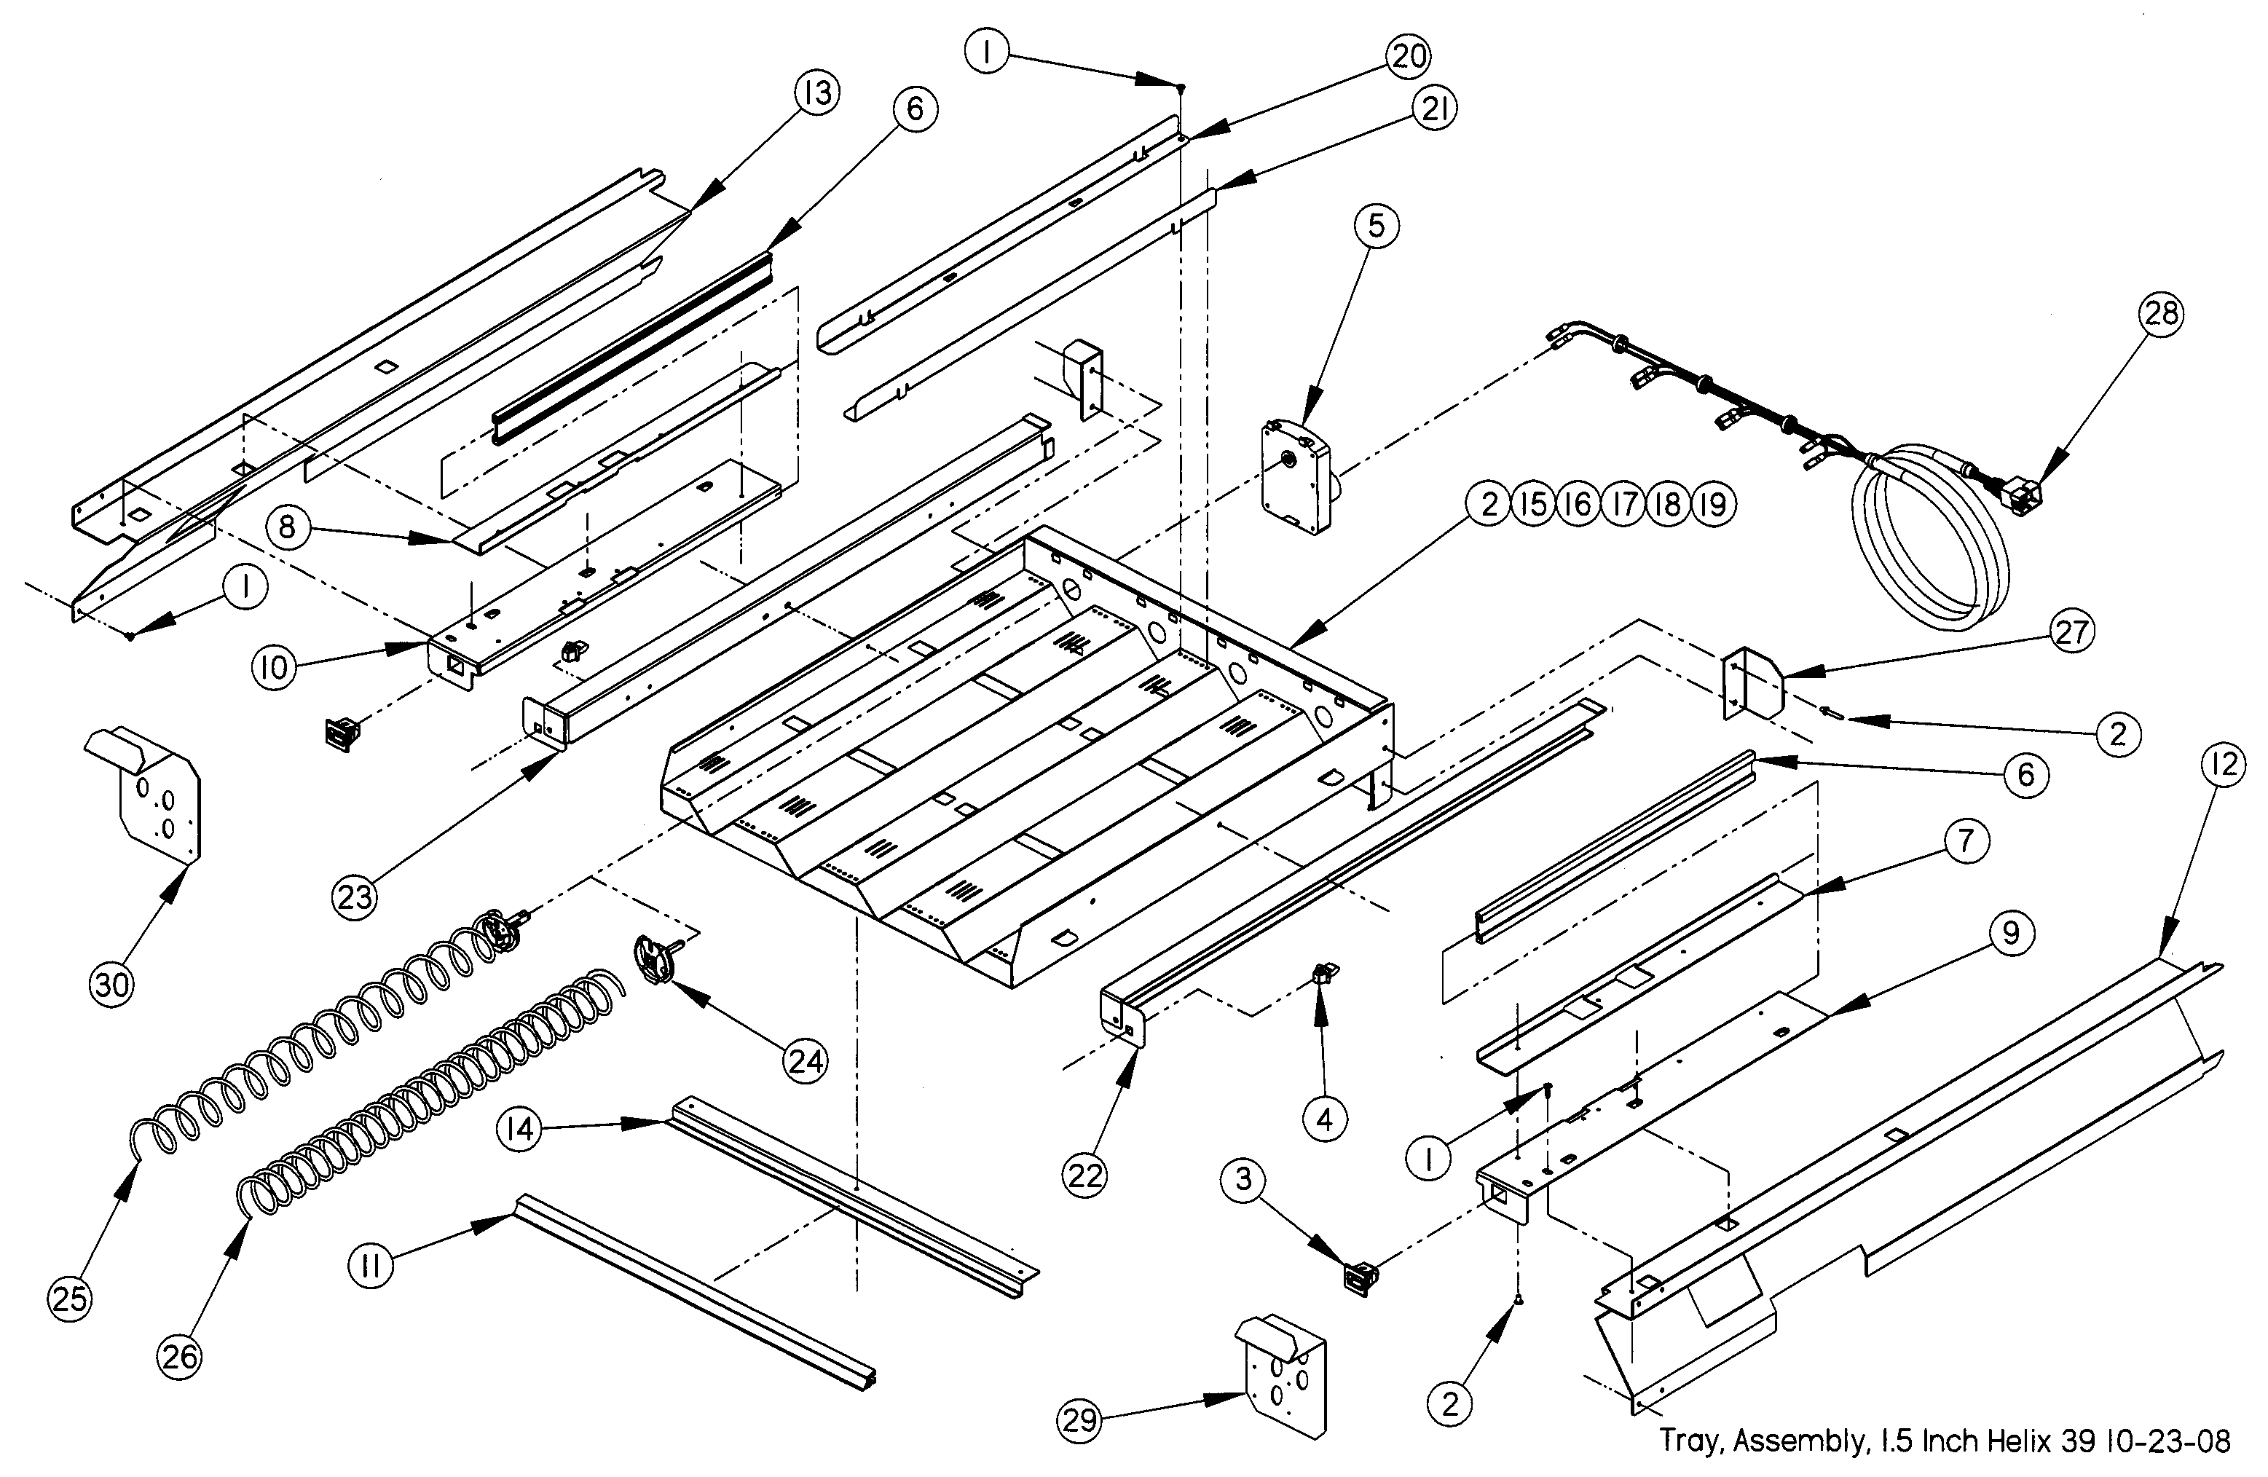

1.5” HELIX TRAY ASSEMBLY PARTS LIST
ITEM NO | PART NO. | PART NAME | QTY | NOTES
 | 21193 | ASSEMBLY, TRAY, 1.5” HELIX
1 | 3000 | SCREW, TEK 8-18 | 18
2 | 3009-02 | RIVET, POP, STEEL, 1/8 | 34
3 | 3246 | LATCH, NYLON, GUM AND MINT | 2
4 | 3247 | STRIKE, NYLON, GUM AND MINT | 2
5 | 20086 | MOTOR, SINGLE HELIX W/O SWITCH | 4
6 | 20236 | EXTRUSION, GUM AND MINT RAIL | 2
7 | 20237 | EXTRUSION MOUNT, UPPER (GUM AND MINT)(RIGHT SIDE) | 1
8 | 20237-01 | EXTRUSION MOUNT, UPPER (GUM AND MINT)(LEFT SIDE) | 1
9 | 20238 | EXTRUSION MOUNT, LOWER (GUM AND MINT)(RIGHT SIDE) | 1
10 | 20238-01 | EXTRUSION MOUNT, LOWER (GUM AND MINT)(LEFT SIDE) | 1
*11 | 20465-04 | EXTRUSION, PRICE MARKER, REDUCED HEIGHT | 1
12 | 20973 | RAIL, GUM AND MINT, REDUCED DEPTH (39”)(RIGHT SIDE) | 1 | RAILS TO FIT TRAY TO 39” CABINET
13 | 20973-01 | RAIL, GUM AND MINT, REDUCED DEPTH (39”)(LEFT SIDE) | 1 | RAILS TO FIT TRAY TO 39” CABINET
14 | 21196 | DOUBLER, TRAY 1.5” HELIX TRAY | 1
15 | 21197 | TRAY BODY, 1.5” HELIX TRAY | 1 | PARTS ARE FACTORY ASSEMBLED AS A UNIT
16 | 21199 | TRAY BACK, 1.5” HELIX TRAY | 1 | PARTS ARE FACTORY ASSEMBLED AS A UNIT
17 | 21200 | TRAY INNER SIDE, 1.5” HELIX TRAY | 2 | PARTS ARE FACTORY ASSEMBLED AS A UNIT
18 | 21201 | TRAY INNER SECTION, 1.5” HELIX TRAY | 2 | PARTS ARE FACTORY ASSEMBLED AS A UNIT
19 | 21202 | TRAY INNER MID SECTION, 1.5” HELIX TRAY | 1 | PARTS ARE FACTORY ASSEMBLED AS A UNIT
20 | 21203 | DIVIDER, TRAY, 1.5” HELIX TRAY, RH | 4
21 | 21203-01 | DIVIDER, TRAY, 1.5” HELIX TRAY, LH | 4
22 | 21204 | TRAY SLIDE CHANNEL,1.5” HELIX TRAY, RH | 1
23 | 21204-01 | TRAY SLIDE CHANNEL,1.5” HELIX TRAY, LH | 1
24 | 21206 | HELIX ADAPTER, 1.5” HELIX TRAY | 4
25 | 21207-15 | HELIX, 1.5” TRAY, COUNTERCLOCKWISE, BLACK | 2 | TRAY IS EQUIPPED WITH TWO OF EACH  SEE HELIX SECTION
26 | 21207-25 | HELIX, 1.5” TRAY, COUNTERCLOCKWISE, BLACK | 2 | TRAY IS EQUIPPED WITH TWO OF EACH  SEE HELIX SECTION
27 | 21523 | BRACKET, STOP, 1.5” HELIX TRAY | 2
28 | 21584 | HARNESS, 1.5” HELIX TRAY | 1
29 | 24252 | KICKER, GUM AND MINT, 39” GEM | 1 | PARTS MAY NOT RESEMBLE ILLUSTRATION
30 | 24252-01 | KICKER, GUM AND MINT LH, 39” GEM | 1 | PARTS MAY NOT RESEMBLE ILLUSTRATION

*Tray also comes in scrolling price option. Contact your distributor for details.

ELECTRICAL HARNESS ILLUSTRATIONS

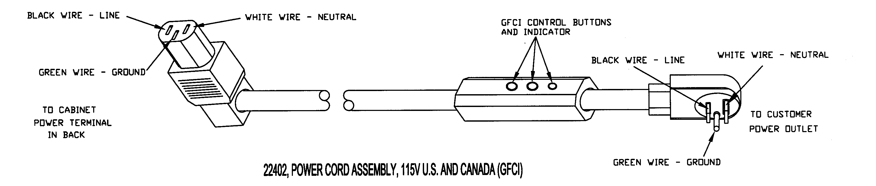
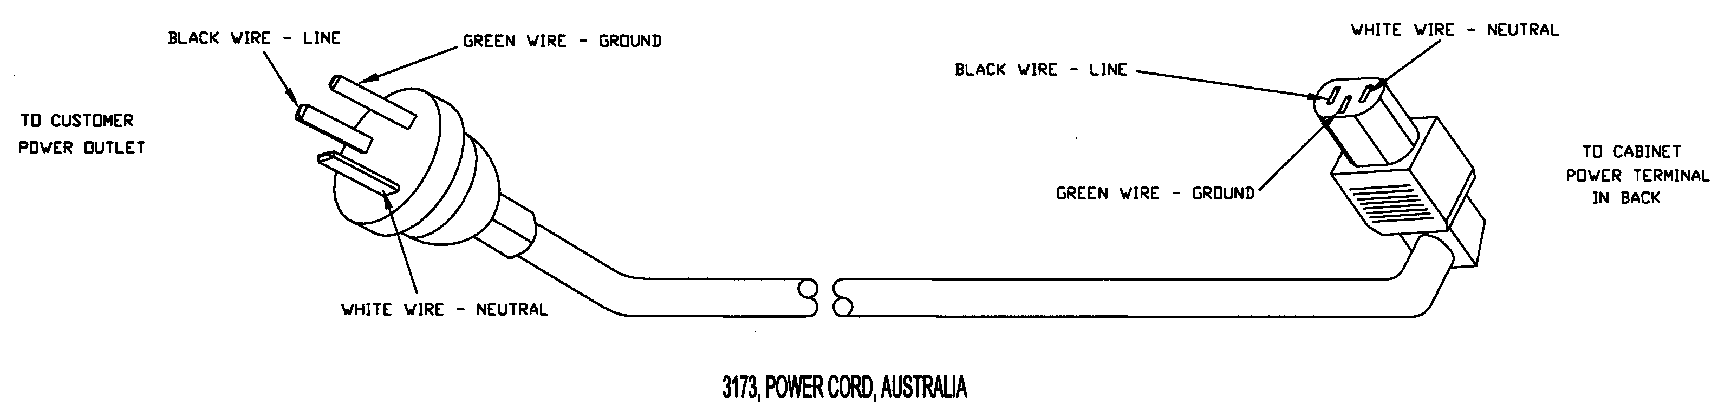
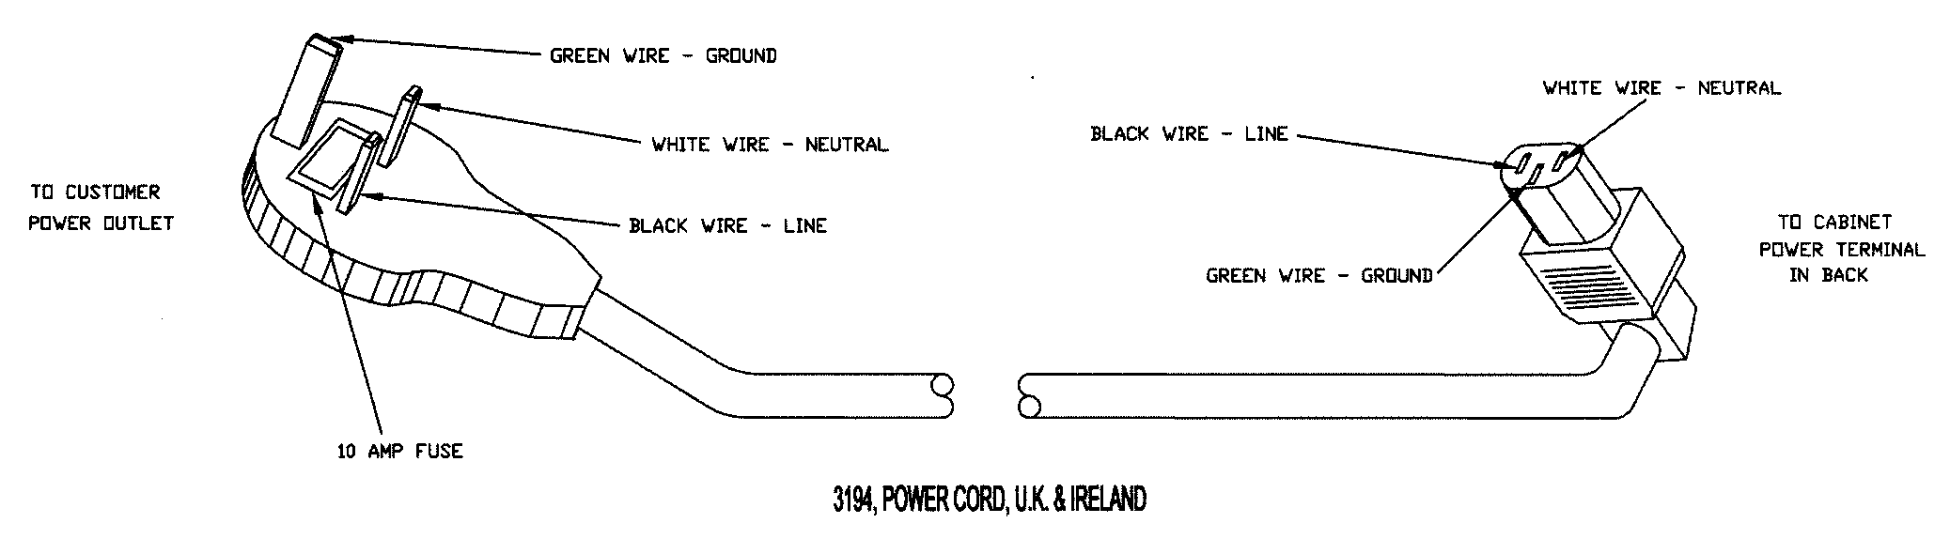

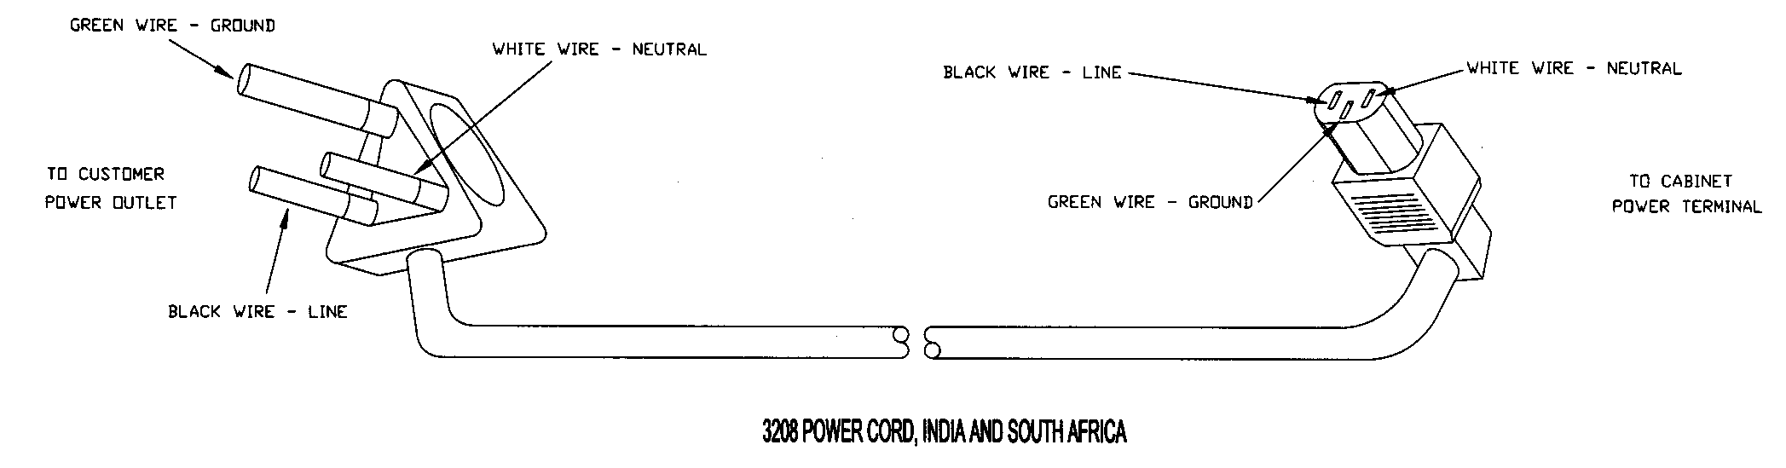

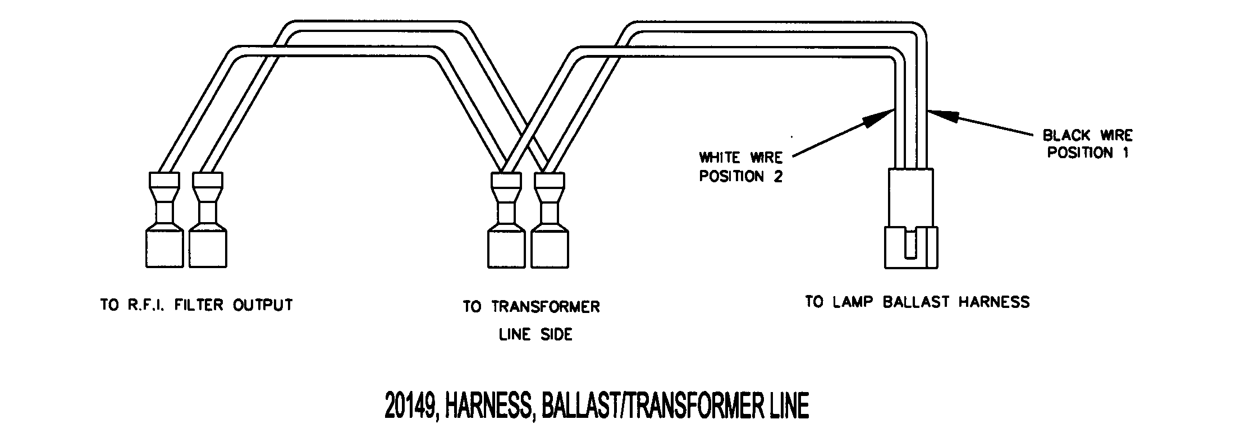

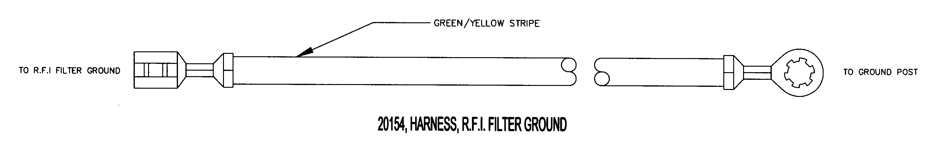

25688, ASSEMBLY, KEYPAD

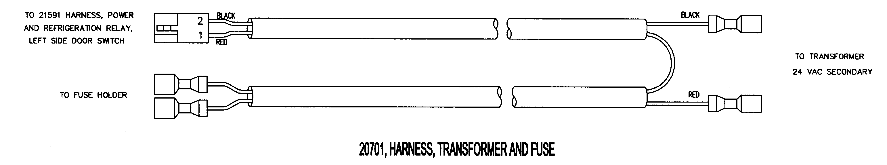

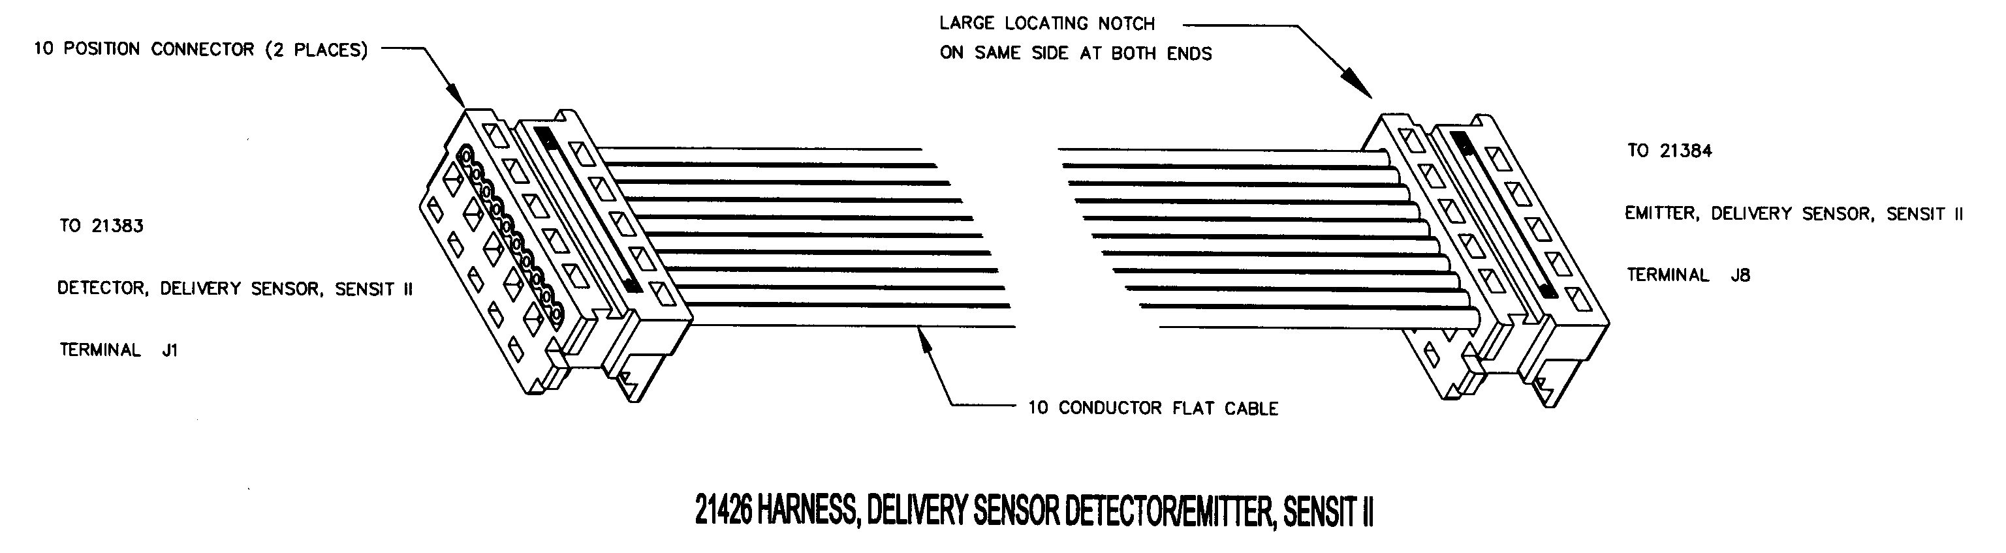

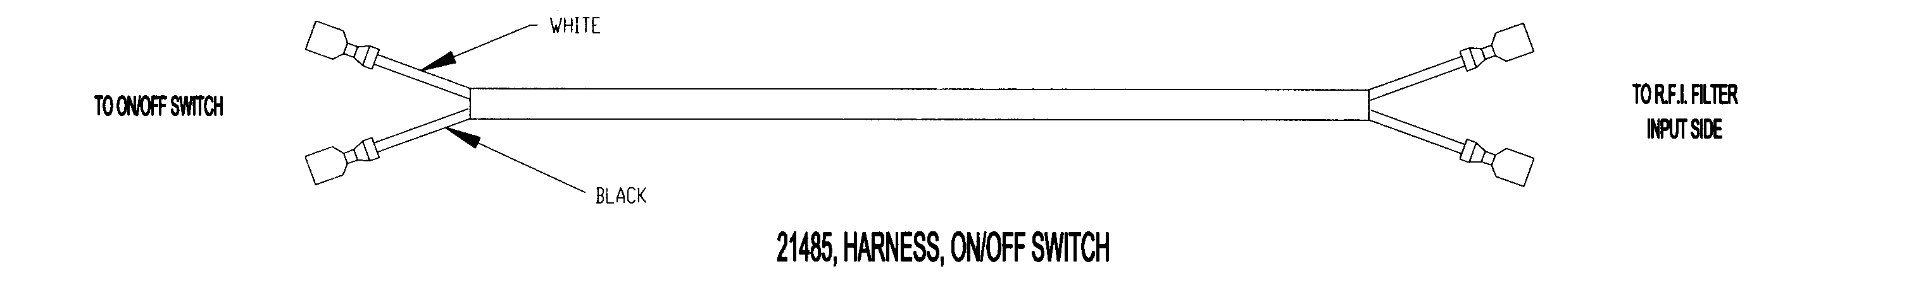

23624, HARNESS, TRANSFORMER, NO BALLAST

PART NO. | PART DESCRIPTION | NOTES
22402 | POWER CORD ASSEMBLY, 115V U.S. AND CANADA
3173 | POWER CORD, AUSTRALIA
3194 | POWER CORD, U.K. AND IRELAND
3208 | POWER CORD, INDIA AND SOUTH AFRICA
20149 | HARNESS, BALLAST/ TRANSFORMER
23503 | HARNESS, DELIVERY SENSOR DETECTOR/CONTROL
21591 | HARNESS, CONTROL POWER AND DOOR SWITCH
20154 | HARNESS, R.F.I. FILTER GROUND
20158 | HARNESS, MULTI-DROP BUS
25688 | ASSEMBLY, KEYPAD
23918 | HARNESS, MOTOR DISTRIBUTION
23901 | HARNESS, SINGLE LAMP 110V | 110V UNITS
24023 | HARNESS, SINGLE LAMP 220V | 220V UNITS
23501 | HARNESS, TRAY, 6 COLUMN | 28” GEM
23357 | HARNESS, POWER INPUT
20701 | HARNESS, TRANSFORMERAND FUSE
20730 | HARNESS, BALLAST, 110V | 110V UNITS
24025 | HARNESS, BALLAST, 220V | 220V UNITS
21426 | HARNESS, DELIVERY SENSOR DETECTOR,
21432 | HARNESS, DISPLAY, SENSIT II
21485 | HARNESS, ON/OFF SWITCH
24271 | HARNESS, LED/MDB EXTENSION | USE WITH LED OPTION, 39” GEM ONLY
20147 | HARNESS, TRAY, 10 COLUMN | 39” GEM
23624 | HARNESS, TRANSFORMER, NO BALLAST | USE WITH LED OPTION
24338 | LIGHTED POS POWER HARNESS

THIS PAGE INTENTIONALLY LEFT BLANK

MODEL 39 HELIX ILLUSTRATIONS

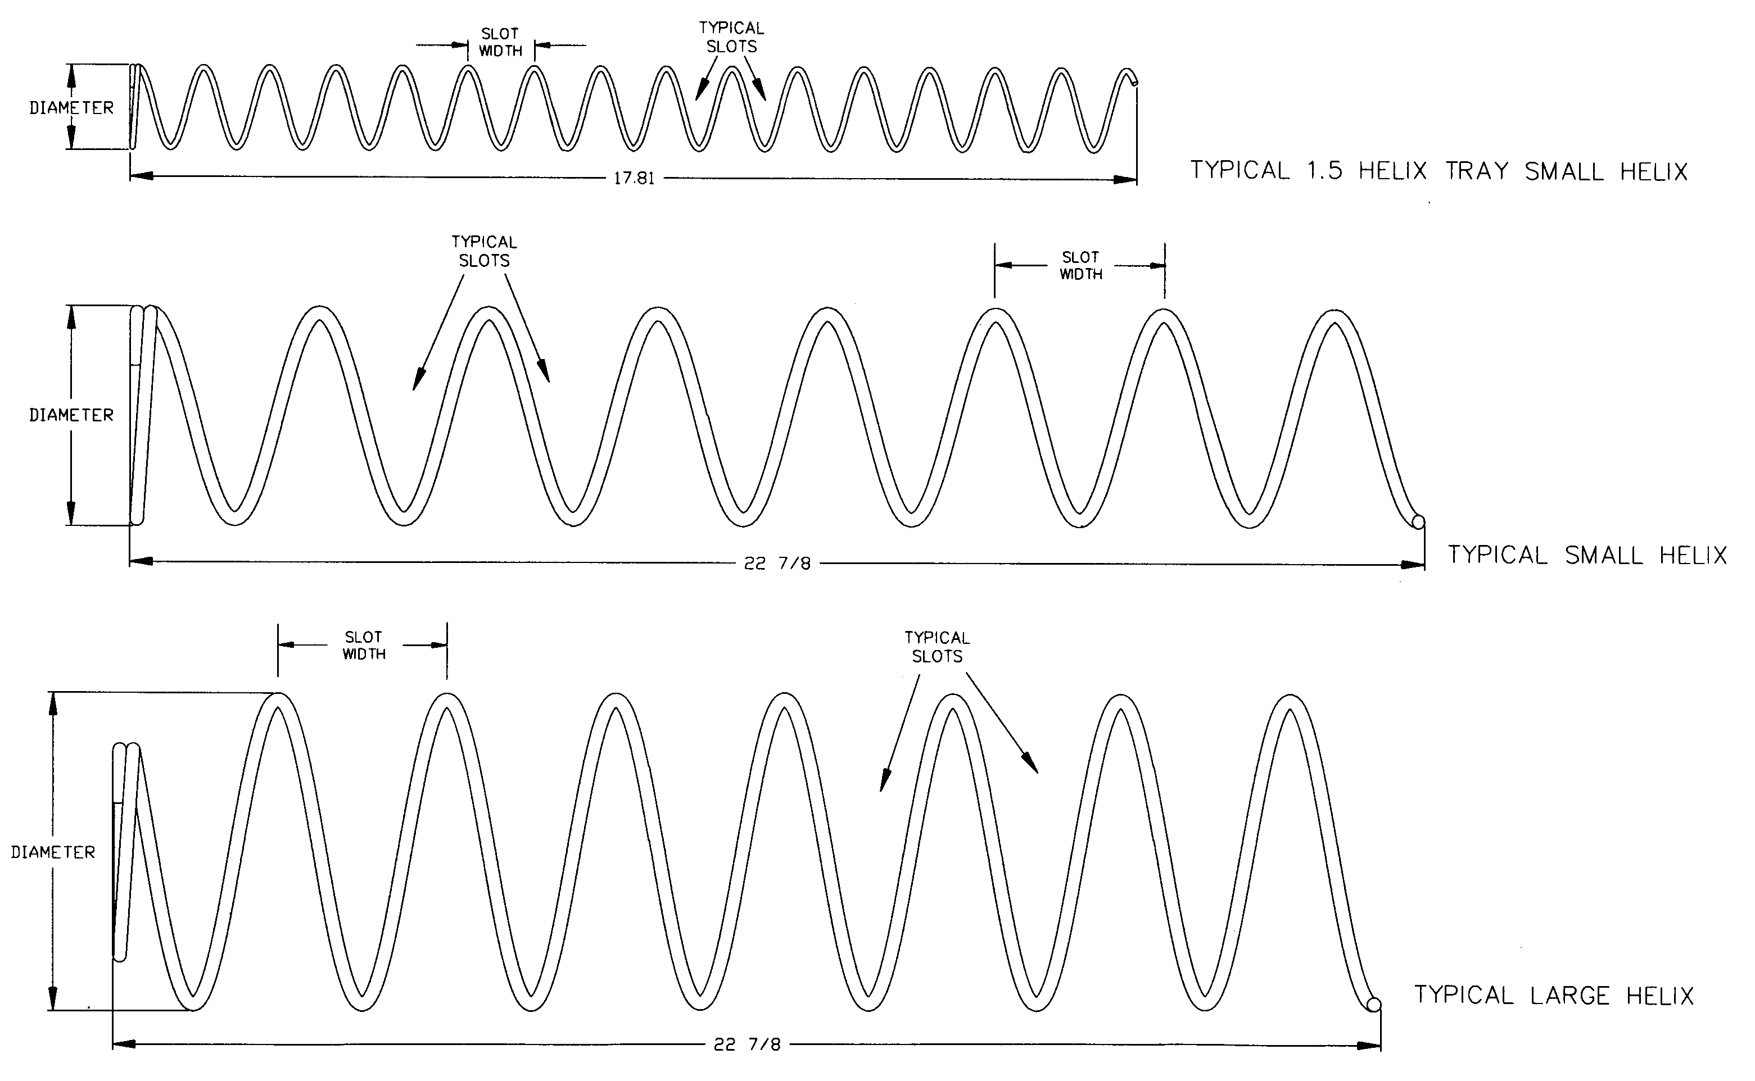

MODEL 39 HELIX PARTS LIST
PART  NO. | HELIX DESCRIPTION * | SLOT  (VEND)  WIDTH | NUMBER  OF SLOTS  (PITCH) | HELIX  OUTSIDE  DIAMETER | TURNS | QTY PER COLUMN | NOTE
20119-07 | Helix, Small CW, Black | 2 5/8 | 7 | 2.6 | CW | 1 Set | Use With 20120-07 As A Set
20120-07 | Helix, Small CCW, Black | 2 5/8 | 7 | 2.6 | CCW | 1 Set
20119-10 | Helix, Small CW, Black | 1 7/8 | 10 | 2.6 | CW | 1 Set | Use With 20120-10 As A Set
20120-10 | Helix, Small CCW, Black | 1 7/8 | 10 | 2.6 | CCW | 1 Set
20120-12 | Helix, Small CCW, Black | 1 7/8 | 12 | 2.6 | CCW | 1
20120-15 | Helix, Small CCW, Black | 1 7/8 | 15 | 2.6 | CCW | 1
20120-18 | Helix, Small CCW, Black | 1 7/8 | 18 | 2.6 | CCW | 1
20120-24 | Helix, Small CCW, Black | 1 7/8 | 24 | 2.6 | CCW | 1
21207-15 | Helix, 1.5”, CCW, Black | 1 | 15 | 1.5 | CCW | 1 | Use in 1.5” Helix Tray
21207-25 | Helix, 1.5”, CCW, Black | 9/16 | 25 | 1.5 | CCW | 1 | Use in 1.5” Helix Tray
21336 | Helix, 3”, CCW, Black | 3.5 | 6 | 3 | CCW | 1 | Bottle Tray
21337 | Helix, 3”, CCW, Black | 3.2 | 6 | 3 | CCW | 1 | Bottle Tray
21465-5 | Helix, 3.75” CCW, Black | 3 ¼ | 5 | 3.75 | CCW | 1 | Large Diameter
21465-7 | Helix, 3.75” CCW, Black | 2 5/8 | 7 | 3.75 | CCW | 1 | Large Diameter
21465-9 | Helix, 3.75” CCW, Black | 2 | 9 | 3.75 | CCW | 1 | Large Diameter
21465-10 | Helix, 3.75” CCW, Black | 1 ¾ | 10 | 3.75 | CCW | 1 | Large Diameter
21465-12 | Helix, 3.75” CCW, Black | 1 ½ | 12 | 3.75 | CCW | 1 | Large Diameter
21465-15 | Helix, 3.75” CCW, Black | 1 ¼ | 15 | 3.75 | CCW | 1 | Large Diameter
23268-10 | Helix, 1.5”, CCW, Black | 2 | 10 | 1.5 | CCW | 1 | Use with Mini-Dispenser Kit
23268-20 | Helix, 1.5”, CCW, Black | 1 1/8 | 20 | 1.5 | CCW | 1 | Use with Mini-Dispenser Kit
23268-32 | Helix, 1.5”, CCW, Black | 5/8 | 32 | 1.5 | CCW | 1 | Use with Mini-Dispenser Kit

Contact your distributor for special helix diameters and pitch.
Contact AMS for your application.

MODEL 28 HELIX ILLUSTRATIONS

MODEL 28 HELIX PARTS LIST
PART  NO. | HELIX DESCRIPTION * | SLOT  (VEND)  WIDTH | NUMBER  OF SLOTS  (PITCH) | HELIX  OUTSIDE  DIAMETER | TURNS | QTY PER COLUMN | NOTE
24061-07 | Helix, 1.5”, CCW, Black | 2 | 7 | 1.5 | CCW | 1 | Use With Mini-Dispenser Kit 24026-01
24061-14 | Helix, 1.5”, CCW, Black | 1 1/8 | 14 | 1.5 | CCW | 1 | Use With Mini-Dispenser Kit 24026-01
24061-23 | Helix, 1.5”, CCW, Black | 5/8 | 23 | 1.5 | CCW | 1 | Use With Mini-Dispenser Kit 24026-01
24031-03 | Helix, 2.6”, CW, Black | 3 5/8 | 3 | 2.6 | CW | 1 Set | Use With 23549-03 To Couple Motors
24031-04 | Helix, 2.6”, CW, Black | 2 3/4 | 4 | 2.6 | CW | 1 Set | Use With 23549-04 To Couple Motors
24031-05 | Helix, 2.6”, CW, Black | 3 | 5 | 2.6 | cw | 1 Set | Use With 23549-05 To Couple Motors
24031-07 | Helix, 2.6”, CW, Black | 2 | 7 | 2.6 | CW | 1 Set | Use With 23549-07 To Couple Motors
24031-08 | Helix, 2.6”, CW, Black | 1 3/4 | 8 | 2.6 | CW | 1 Set | Use With 23549-08 To Couple Motors
24031-10 | Helix, 2.6”, CW, Black | 1 3/8 | 10 | 2.6 | CW | 1
23549-03 | Helix, 2.6”, CCW, Black | 3 5/8 | 3 | 2.6 | CCW | 1
23549-04 | Helix, 2.6”, CCW, Black | 3 1/8 | 4 | 2.6 | CCW | 1
23549-05 | Helix, 2.6”, CCW, Black | 3 | 5 | 2.6 | CCW | 1
23549-06 | Helix, 2.6”, CCW, Black | 2 1/4 | 6 | 2.6 | CCW | 1
23549-07 | Helix, 2.6”, CCW, Black | 2 | 7 | 2.6 | CCW | 1
23549-08 | Helix, 2.6”, CCW, Black | 1 3/4 | 8 | 2.6 | CCW | 1
23549-11 | Helix, 2.6”, CCW, Black | 1 .5 | 11 | 2.6 | CCW | 1
23549-13 | Helix, 2.6”, CCW, Black | 1 3/16 | 13 | 2.6 | CCW | 1
23549-17 | Helix, 2.6”, CCW, Black | 1 | 17 | 2.6 | CCW | 1
23976-03 | Helix, 3.75”, CCW, Black | 4 1/4 | 3 | 3.75 | CCW | 1
23976-04 | Helix, 3.75”, CCW, Black | 3 5/8 | 4 | 3.75 | CCW | 1
23976-05 | Helix, 3.75”, CCW, Black | 2 3/4 | 5 | 3.75 | CCW | 1
23976-06 | Helix, 3.75”, CCW, Black | 2 1/4 | 6 | 3.75 | CCW | 1
23976-07 | Helix, 3.75”, CCW, Black | 2 | 7 | 3.75 | CCW | 1
23976-09 | Helix, 3.75”, CCW, Black | 1 3/4 | 9 | 3.75 | CCW | 1
23976-11 | Helix, 3.75”, CCW, Black | 1 3/8 | 11 | 3.75 | CCW | 1
23976-17 | Helix, 3.75”, CCW, Black | 1 | 17 | 3.75 | CCW | 1
Contact your distributor for special helix diameters and pitch. Contact AMS for your application.

